Vietnam Tourism

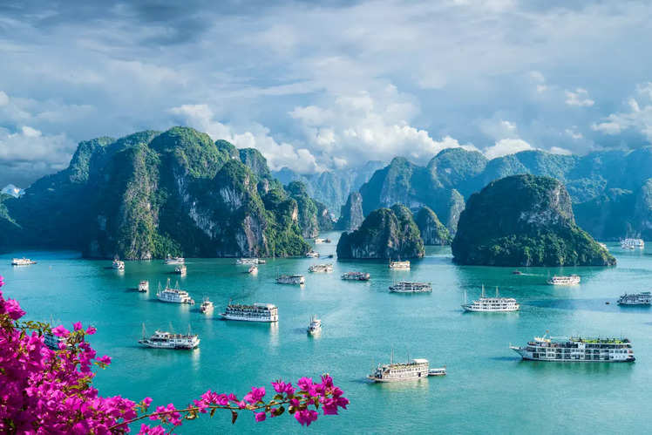
Vietnam is a dynamic Southeast Asian country known for its rich history, diverse culture, and stunning landscapes. Its capital is Hanoi, and the largest city is Ho Chi Minh City. With a population of about 100 million, Vietnam is a one-party socialist republic. It boasts natural wonders like Ha Long Bay, lush rice terraces in Sapa, and the Mekong Delta.
Historically, Vietnam has overcome colonization by France and the Vietnam War, emerging as a unified, fast-developing nation. Its economy thrives on agriculture, manufacturing, and tourism, while its cuisine, including dishes like pho and banh mi, is globally celebrated. Official Name: Socialist Republic of Vietnam
Capital City: Hanoi Largest City: Ho Chi Minh City Language: Vietnamese
Currency: 1 Rs INR = 303 Vietnamese đồng (VND) Time Differences : Vietnamese is 1.5 Hrs Ahead of India

Visa: Electronica Visa Must Eat Food: Banh mi(Famous sandwich) & Pho: Noodle Soup

Tourism Highlights

Iconic Cities: Hanoi: The capital city blends old and new with landmarks like Hoan Kiem Lake, the Old Quarter, and the Temple of Literature. Don’t miss the traditional water puppet shows.
Ho Chi Minh City (Saigon): A bustling metropolis featuring the War Remnants Museum, Notre Dame Cathedral, and Ben Thanh Market. Hue: The former imperial capital, known for the Citadel, royal tombs, and pagodas along the Perfume River. Hoi An: A UNESCO-listed ancient town with well-preserved architecture, colorful lanterns, and riverside charm.

Natural Wonders: Ha Long Bay: A UNESCO World Heritage Site, famous for its emerald waters and towering limestone karsts. Explore by cruise, kayak, or seaplane. Phong Nha-Ke Bang National Park: Home to incredible caves like Son Doong (the largest cave in the world) and Paradise Cave. Sapa and the Northern Highlands: Known for its terraced rice fields, ethnic hill tribes, and trekking opportunities. Mekong Delta: A lush region with floating markets, rice paddies, and rural villages.

Beaches and Islands: Phu Quoc Island: A tropical paradise with white-sand beaches, coral reefs, and luxury resorts. Nha Trang: A lively beach town offering water sports, mud baths, and Vinpearl Amusement Park. Da Nang: Famous for My Khe Beach, Marble Mountains, and the Golden Bridge with its "giant hands." Con Dao Islands: A remote archipelago known for pristine beaches, marine life, and sea turtle nesting sites.

Historical and Cultural Landmarks: Cu Chi Tunnels: Explore the vast underground network used during the Vietnam War. My Son Sanctuary: A UNESCO-listed site with ancient Hindu temple ruins amidst lush greenery. Hoa Lu (Ninh Binh): The ancient capital of Vietnam surrounded by stunning karst landscapes. Ba Dinh Square (Hanoi): Visit Ho Chi Minh’s Mausoleum, the Presidential Palace, and the One Pillar Pagoda.

Culinary Delights: Pho: Vietnam’s iconic noodle soup, available in northern (Hanoi-style) or southern variations. Banh Mi: A fusion baguette sandwich filled with meats, pickled vegetables, and herbs. Fresh Spring Rolls (Goi Cuon): Light rice paper rolls with shrimp, pork, and fresh herbs. Street Food: Sample dishes at local markets, from Hanoi’s Old Quarter to Ho Chi Minh City’s Ben Thanh Market.

Adventure Activities: Trekking and Homestays: Sapa and Ha Giang offer treks through terraced fields and stays with local ethnic tribes. Cycling in the Mekong Delta: Explore rural life and lush landscapes on two wheels. Cave Exploration: Phong Nha offers caving adventures, from easy walks to multi-day expeditions in Son Doong. Sandboarding: Try sandboarding or quad biking on the dunes in Mui Ne.

Scenic Experiences: Cruising Ha Long Bay: Witness the magical seascape with overnight cruises or day trips. Boat Rides in Ninh Binh: Sail through caves and karst landscapes at Tam Coc or Trang An. Train Journey: Travel from Hanoi to Ho Chi Minh City on the Reunification Express for stunning coastal and countryside views.

Spiritual and Religious Sites: Perfume Pagoda (Hanoi): A sacred Buddhist site nestled in limestone hills, accessible by boat. Cao Dai Temple (Tay Ninh): A vibrant temple representing the Cao Dai religion, blending elements of Buddhism, Christianity, and Confucianism. Thien Mu Pagoda (Hue): A historic seven-story pagoda overlooking the Perfume River.

Shopping and Markets: Night Markets: Find souvenirs, food, and crafts in places like Hanoi’s Old Quarter and Hoi An. Floating Markets: Experience Cai Rang or Phong Dien markets in the Mekong Delta for a unique shopping adventure. Silk and Tailoring: Hoi An is famous for its custom tailoring and high-quality silk products.

Modern Marvels: Landmark 81 (Ho Chi Minh City): Vietnam’s tallest skyscraper with observation decks and luxury shopping. Dragon Bridge (Da Nang): A dragon-shaped bridge that lights up with fire and water displays at night.

VIETNMAN
(5 Nights 6 Days)
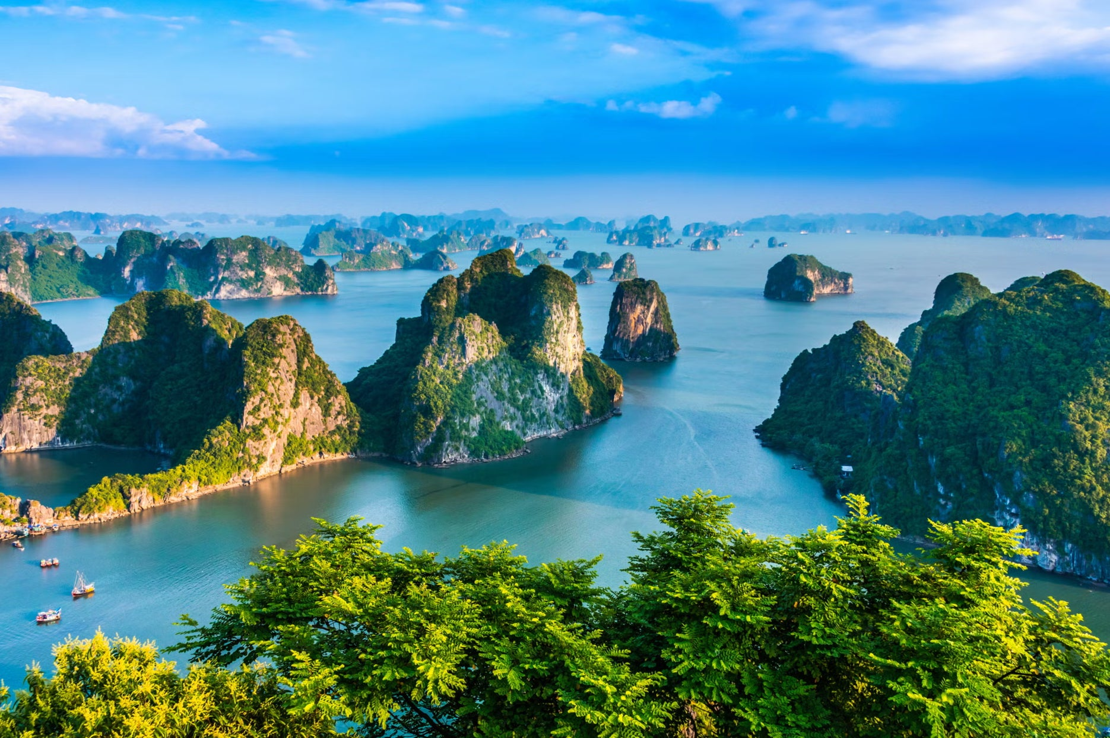

Day 1: Arrival Hanoi Vietnam. City tour
Our driver, no guide will meet and welcome you at Noi Bai international airport. Transfer you to Hanoi downtown for check in.
Check in time is 14.00 – early check in subject to availability

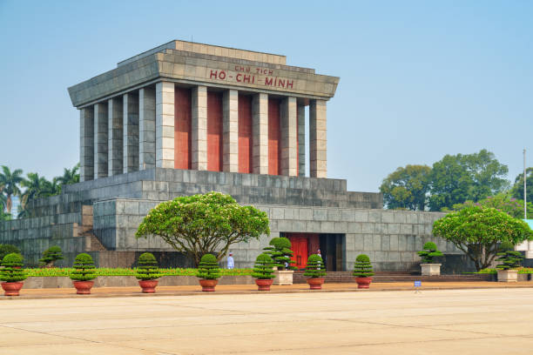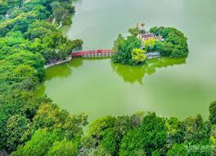

Afternoon, visit Ba Dinh Square with Hochiminh Mausoleum (closed on every Monday, Friday), One Pillar Pagoda and Hochiminh’s House of Stilt Then visit Temple of Literature (the 1st National University of Vietnam), Sword Lake with Ngoc Son Temple and The Huc Bridge Continue to visit & shopping at Old Quarter (36 ancient wards & streets) and Dong Xuan Market
Overnight in Hanoi

Day 2: Tam Coc full day tour (B/L) SIC
After breakfast, depart for Ninh Binh which owns Hoa Lu and Tam Coc as the most favorite sightseeing of tourists from all over the world.

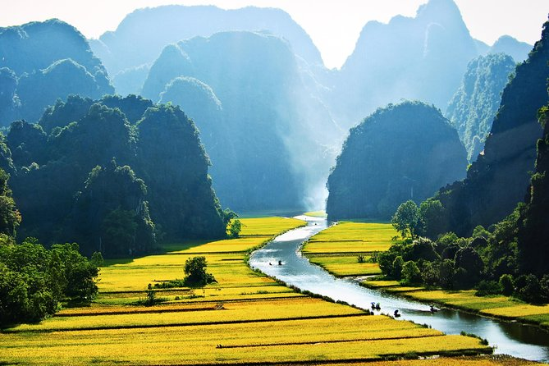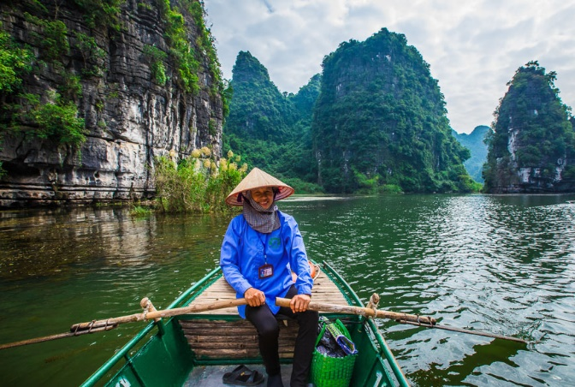

After 2 hours, you will arrive at Hoa Lu Ancient Capital. In 968, Dinh Bo Linh declared himself as the King. Since then Hoa Lu existed as the capital for the next 41 years (968 – 1009), of which 12 years was under the Dinh dynasty – King Dinh Tien Hoang, the country named Dai Co Viet, and 29 years later was under the Le dynasty – King Le Dai Hanh. In 1010, King Ly Thai To moved the capital from Hoa Lu to Thang Long – present day Hanoi. Hoa Lu became the old citadel. In Hoa Lu there are now 2 temples have been built on the ground of the old royal palace, one is dedicated to King Dinh Tien Hoang, the other is to King Le Dai Hanh. The visit offers a chance to know more about part of feudal dynasties and historical periods in Vietnamese history.

Afternoon, 5 minute-walk to the boat station and start the 2hour-boat trip to visit Tam Coc. Known as “Halong Bay on land”, Tam Coc are three limestone caves stretching along Ngo Dong river. The boat trip is a nice journey along the river with peaceful scenery of Limestone Mountains, rice paddy and the site of some temples along the way from Hang Ca (first cave) to Hang Hai (second cave) and Hang Ba (third cave).
Back to Hanoi in late afternoon.
Stay overnight in Hanoi

Day 3: Hanoi – Halong. Stay overnight on board (B,L,D)
Note: Transfer Hanoi – Halong Bay – Hanoi by cruise shuttle bus
Your morning departure from your hotel in Hanoi to Halong Bay takes you on a journey through the rich farmlands of the Red River Delta. Observe everyday life of Vietnamese Villages as you see the villagers work the local rice fields, take live pigs to market on bicycles and plough the fields with their large water buffaloes.

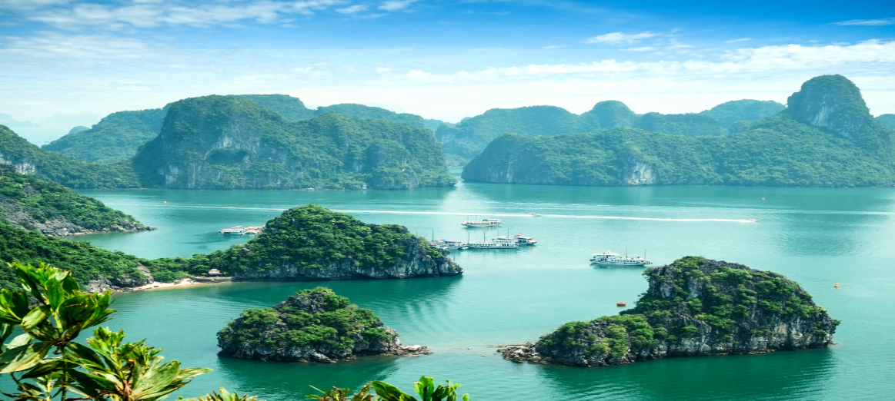

Arrive in Halong and board a traditional sailing junk. As the vessel sets sails, you will be greeted by the Crew Team who will aim throughout your stay at providing you with the highest standards of service for a pure pleasure and utmost comfort onboard. Discover some of the treasures disseminated across the Bay of the Descending Dragon during the afternoon: fascinating caves, pristine beaches, picturesque floating villages, fantastic rock formations rising up out of emerald water. While onboard, you can take advantage at leisure of the cruise services; surrounded by a stunning setting in motion, you could attend our chef's cooking demonstration and try your skills in the art of traditional Vietnamese cooking.

Defined to be one of the highlights of your stay, a highly refined, innovative and varied cuisine will be presented for Lunch and Dinner in the elegant dining-room, accompanied by a wide selection of wines and beverages (with extra charge applied) for drink).

In the evening enjoy the entertainment activities as movie night, squid fishing or just enjoying a cocktail surrounded by limestone rocks majestically springing out from silent waters in the night.

Stay overnight in a cruise in Halong.

Day 4: Halong – Hanoi. Flight to Danang (B,brunch)

Early birds can attend a Tai Chi demonstration on the sundeck at the break of dawn. Start the day enjoying some delights with a light breakfast and follow by a colorful brunch.. Continue exploring Halong Bay sailing across its 2000 islets and visiting some of its major highlights.

Shuttle bus of cruise will drop you off at Hotel’ lobby. Then, our driver (no guide) will pick you up and transfer to airport for flight to Da Nang.

Arriving at Danang Airport, you’ll be welcomed and picked up by our Driver (No guide) , then be transferred to your hotel.
Stay overnight in Danang.

Day 5: Bana Hill tour & Golden Bridge (B/L) SIC
After breakfast, transfer to Bana Hills Station for Ba Na Hills 1-day tour. You have a chance to ride on a modern system of cable cars helps you get a birds-eye view, very miraculous and attractive while enjoying a feeling of flying in the blue sky amidst the clouds and wind.

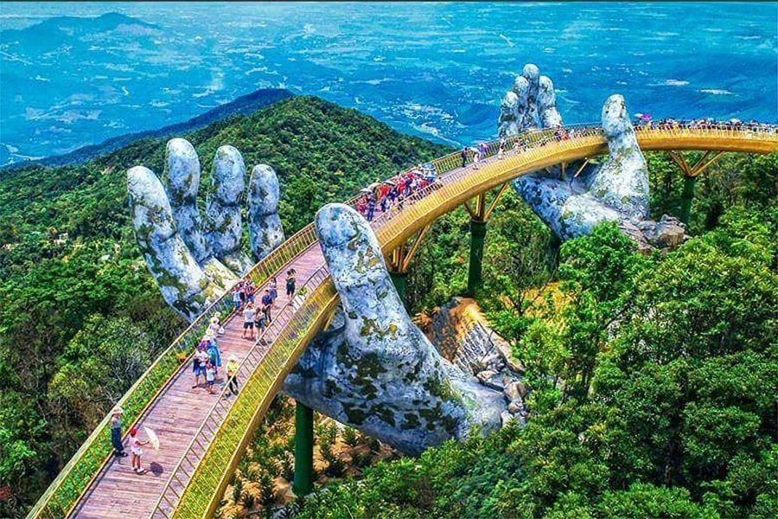

Enjoy Golden Bridge at Ba Na Hill. The bridge is located at a height of 1,400M, between a sea of clouds. Standing here watching the scene that has taken photos, the more and more, make sure not to harm anyone.
Your overnight stay is in Danang.

Day 6: Half day Hoi An Excursion (Private tour) – Drop to Airport – No guide
After breakfast, it is light excursion to go around tiny town of Hoi An for city tour: 400 years old Japanese Bridge, 300 years old Chinese temple, 200 years old Vietnamese former merchants' house.

Afternoon drop to Airport. (No guide)

Tour Ends

