Uzbekistan Tourism

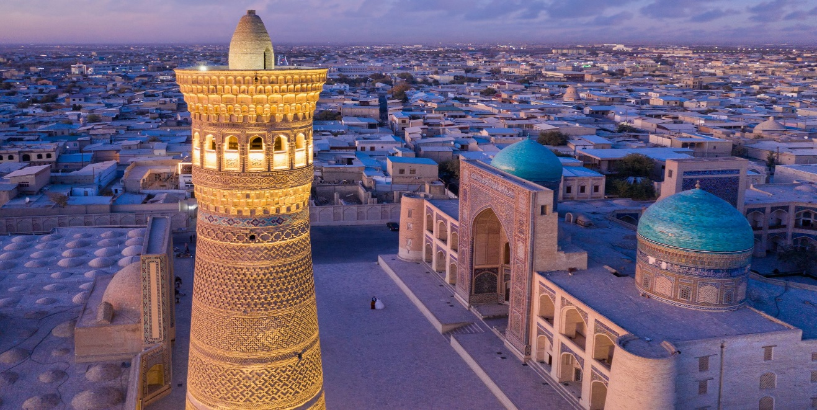

UZBEKISTAN
Located in the heart of the Central Asia, the Republic of Uzbekistan is famous for its numerous architectural monuments, incredible natural landscapes, magnificent palaces, and ruins of fortresses of past civilizations, outstanding cultural events, gastronomic delights and famous craft workshops.
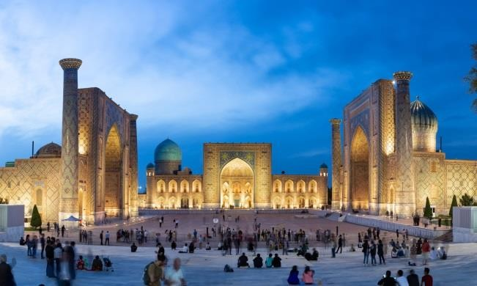
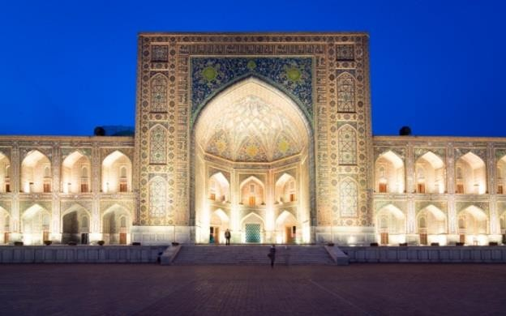

From the first visit, our country evokes extraordinary feelings that prompt us to come here repeatedly. The Republic of Uzbekistan includes 12 regions and the autonomous Republic of Karakalpakstan.
Each corner of Uzbekistan attracts with its features. In Tashkent, you can take a walk in the most beautiful metro in the world or see the most ancient manuscript the Koran of Usman.

In the historical cities included in the UNESCO Cultural Heritage List – Samarkand, Bukhara, Shakhrisabz and Khiva, you can visit the most ancient architectural monuments that have preserved echoes of past eras. In the southernmost part of the country – Surkhandarya, you can travel through mountain gorges or see the ruins of the ancient cities near Termez.

Geographical and space location: The Planet Earth, Eurasian continent, Central Asia Area: 447.4 thousand square km. Population: 34 million Nations: more than 134 nations live in the country, but the majority of the population is Uzbek (83.8%) Regions: 12 regions + Republic of Karakalpakstan

Famous cities: Tashkent, Samarkand, Bukhara, Khiva, Shakhrisabz, Termez, Kokand, Ferghana, Muynak.

Capital: Tashkent Language: the official language is Uzbek, and Russian and English are the languages of international communication.

Religion: Uzbekistan is a secular country, most of the population professes Islam. The country is also home to representatives of Christianity, Buddhism and other religions.

Time zone: India is 30 Mns Ahead of UZbekistand International phone code: +998

Monetary unit: 1 Rs INR = 150 sum Climate: mild winters, hot summers

Visa: E- Visa

UZBEKISTAN
(DELHI – TASHKENT – SAMARKAND - CHARVAK –– DELHI)
( 3 Nights 4 Days)

DAY 1 : DELHI-TASHKENT- WELCOMES YOU

- Arrival in Tashkent @ 10:50hrs and Customs will take about 01 Hour.

- Our Airport Executive will be waiting outside the Airport with Placard.

- Transfer Restaurant -Hotel by bus/ Check-in to the Hotel

- Lunch at Indian Restaurant

- Transfer for Evening City Tour at 16.00 Hrs

Independence Square in Tashkent, Uzbekistan, is a significant landmark featuring monuments celebrating the country's independence and is a central spot for national events and parades

Tashkent Broadway is a vibrant pedestrian street in Tashkent, Uzbekistan, connecting Amir Temur Square and Independence Square, known for its lively atmosphere with street artists, musicians, and entertainers

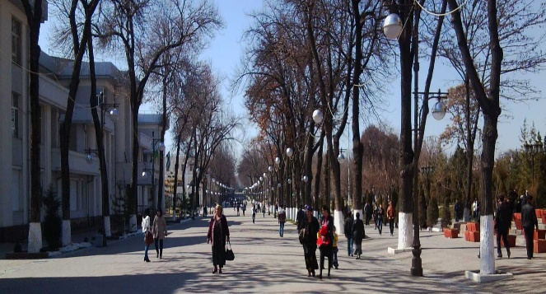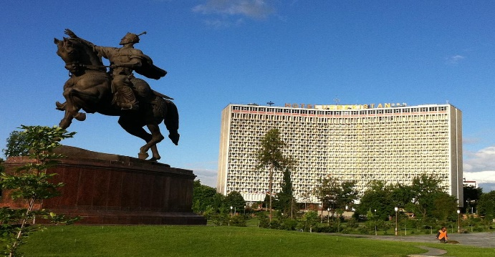

Amir Temur Square in Tashkent, Uzbekistan, is a prominent public square featuring a statue of Amir Temur and surrounded by important cultural and historical landmarks.
- 20:00hrs Transfer to an Indian Restaurant for Dinner

- Transfer back to Hotel at 22.00 Hrs

DAY 2 TASHKENT- SAMARKAND DAY TOUR (Bullet train tickets are subjected to availability)
- 06.00 Hrs Earlybuffetbreakfast

- 07.00 Hrs Transfer to Railway Station for the Bullet Train “Afrosiab” Distance of 350 KMS would be covered in 2.00Hrs only. 10.10 AM arrival at Samarkand Railway Station. Samarkand: Samarkand is the former capital of Great Amir Temur.

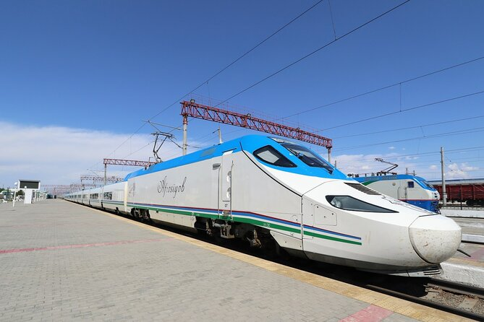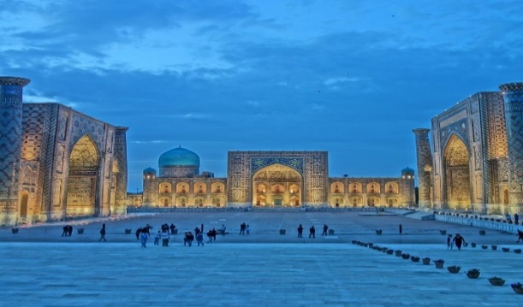

- Samarkand Tours:

  - RegistonSquare is a majestic public square surrounded by three stunning madrasahs (Islamic schools) with intricate tilework and grand architecture, making it a symbol of the city's rich history and cultural heritage

  - GuriEmirMausoleum is a magnificent tomb of the conqueror Timur (Tamerlane) and a masterpiece of Persian-Mongolian architecture.

  - BibikhanymMosque , is a grand mosque built by Timur in honor of his wife, showcasing impressive architecture and intricate design.

  - Siob Local Bazaar in Samarkand, Uzbekistan, is a bustling marketplace known for its vibrant atmosphere, offering a variety of fresh produce, spices, and traditional goods

- 13.30 Hrs Lunch at the Uzbek Restaurant.

- 16.30 Hrs Transfer back to Samarkand Railway station.

- 19.00 Hrs Arrive Tashkent and Some time to relax at Hotel.

- 20.00 Hrs Transfer to an Indian Restaurant for Dinner

- 22.30 Hrs Transfer Back to Hotel and overnight at Hotel

PLEASE NOTE ALL MONUMENTS TO BE SEEN FROM OUTSIDE ONLY. GUEST MAY PAY DIRECTLY AT THE TICKET COUNTERS IF WISH TO SEE MONUMENTS FROM INSIDE.

DAY3 TASHKENT – CHARVAK – CHIMGAN MOUNTAINS - TASHKENT
- Breakfast 07:00 hrs – 10.00 Hrs

- 10.00 hrs Visit Charvak and Chimgan mountains about 125 KMS from Tashkent. Nicknamed Switzerland of Uzbekistan, this area is famous with Tashkent residents and guests as a recreational area. Chair lift takes you to the top of the mountain from where you enjoy breathtaking views, you must take some time for photo shooting!

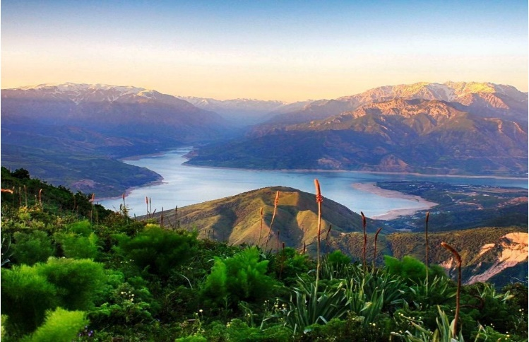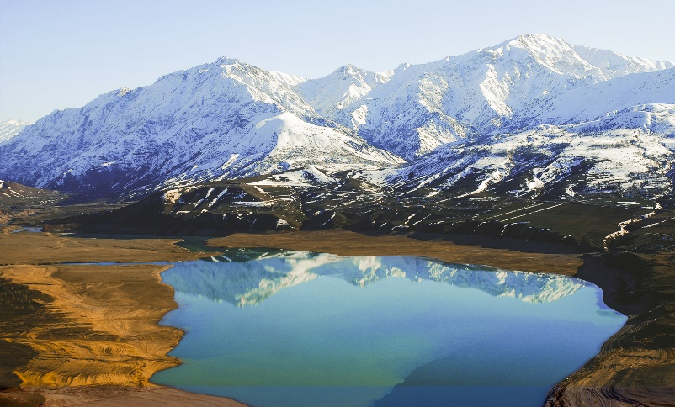

- 14:30hrs Lunch in Pyramids resort in Chimgan Mountains

- 15:30hrs Free time to explore Charvak Artificial Reservoir & You may try your hands on Skiing, Ice skating, Snow Bikes, Horse riding, Local Kebabs with Vodka on your own cost.

- 18:00hrs Transfer back to Tashkent & Check in, Relax for a while

- 20:00hrs Transfer to an Indian Restaurant for Dinner

- Overnight at Hotel

DAY 4 CHECK OUT - TOUR TO LOCAL MARKET - MEGA MALL
- Breakfast 07.00 Hrs – 10.00 Hrs

- Check out from Hotel @ 11.00 Hrs

- 11:30 Hrs Shopping Tour Alaskey Bazar and TSUM

- 14:30 Hrs Lunch in an Indian restaurant( optional)

- 15.30 Hrs Transfer to Mega Planet Shopping Mall and Samarkand Daroza

- Transfer to Tashkent International Airport for your onward Journey

Please Note: There might be changes to the above mentioned Itinerary however, smaller might be but it will be aimed to enhance and optimize your experience with us

Tour Ends

