Turkey Tourism
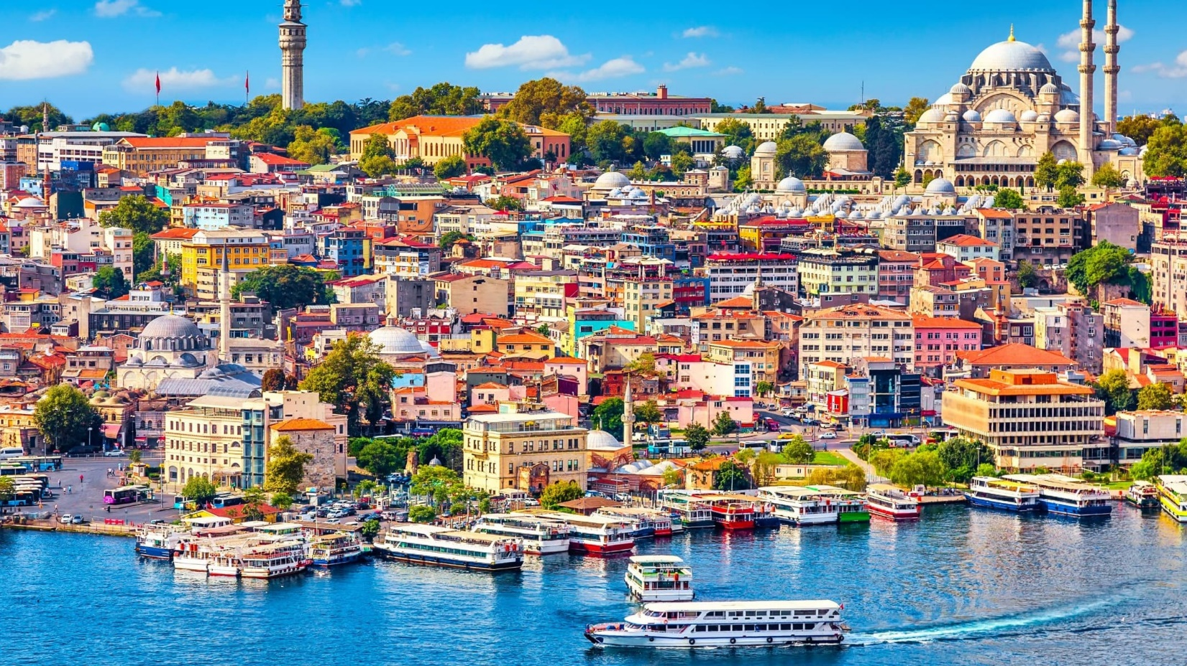
Official Name: Republic of Turkey Capital: Ankara Largest City: Istanbul
Language: Turkish Currency: 1 TRY = 2.20 INR Time Difference: India is Ahead 2.5 Hrs
Visa : E – visa or Sticker Muse Eat Food: Baklava(dessert), doner kebab

Tourism Highlights

Iconic Historical Sites: Hagia Sophia (Istanbul): A stunning architectural marvel that transitioned from a church to a mosque and now a museum. Topkapi Palace: The former residence of Ottoman sultans, showcasing opulent artifacts and panoramic views of the Bosphorus. Ephesus (Selçuk): A UNESCO World Heritage Site and one of the best-preserved ancient cities, featuring the Library of Celsus and the Great Theater. Troy (Çanakkale): Explore the legendary city of Troy and its reconstructed wooden horse.

Natural Wonders: Pamukkale : Famous for its white travertine terraces filled with thermal waters, and the nearby ancient city of Hierapolis. Cappadocia: Known for its unique "fairy chimneys," hot air balloon rides, and underground cities like Derinkuyu and Kaymakli. Mount Nemrut (Adıyaman): A UNESCO World Heritage Site with colossal statues and an ancient royal tomb. Lake Van: Turkey's largest lake, surrounded by picturesque mountains and historic sites like Akdamar Island.

Cities Attractions: Istanbul: A dynamic city where East meets West, featuring the Grand Bazaar, Blue Mosque, and bustling Bosphorus cruises. Ankara: The capital city, home to Atatürk’s Mausoleum and the Museum of Anatolian Civilizations. Izmir: A coastal city with a laid-back vibe, vibrant bazaars, and proximity to Ephesus. Antalya: The gateway to the Turkish Riviera, known for its beaches, historic old town (Kaleiçi), and ancient ruins.

Turkish Riviera (Turquoise Coast): Bodrum: A chic seaside town with luxury resorts, ancient ruins, and the iconic Bodrum Castle Fethiye: Home to the stunning Oludeniz Lagoon, Butterfly Valley, and the Lycian Way trekking route. Antalya Beaches: Lara and Konyaaltı beaches are popular for their clear waters and scenic backdrops. Kaş and Kalkan: Charming coastal towns offering diving, yachting, and hidden coves.

Religious and Spiritual Sites: Mevlana Museum (Konya): The resting place of Rumi, the famous Sufi poet and mystic. Sumela Monastery (Trabzon): A breathtaking cliffside monastery nestled in the forests of the Black Sea region. Göbekli Tepe (Şanlıurfa): An archaeological site considered the world’s oldest temple.

Outdoor Adventures : Hot Air Ballooning (Cappadocia): Witness surreal landscapes from above in one of Turkey’s most iconic experiences. Trekking and Mountaineering: Explore routes like the Lycian Way, Mount Ararat, and the Kaçkar Mountains. Ski Resorts: Uludağ and Erciyes are popular winter destinations for skiing and snowboarding.

Culinary Experiences: Turkish Cuisine: Savor classics like kebabs, baklava, Turkish delight, and mezes. Tea and Coffee Culture: Experience traditional Turkish tea and coffee in historic cafes. Bazaars and Food Markets: Explore Istanbul’s Grand Bazaar and Spice Bazaar for local flavors and ingredients.

Traditional Arts and Crafts: Carpets and Kilims: Handmade Turkish rugs are renowned for their intricate designs. Pottery (Avanos): Cappadocia’s pottery workshops are famous for their red clay ceramics. Whirling Dervishes: Witness mesmerizing Sufi dance performances in places like Konya.

Seaside Escapes and Islands: Princes' Islands (Istanbul): A peaceful retreat with horse-drawn carriages and charming streets Çeşme: Known for its beaches, thermal springs, and windsurfing. Bozcaada and Gökçeada: Tranquil Aegean islands perfect for nature lovers.

Wellness and Spa Experiences: Turkish Baths (Hammams): Enjoy a traditional hammam experience in Istanbul’s historic bathhouses like Çemberlitaş or Cağaloğlu. Thermal Springs: Pamukkale and Yalova are known for their healing thermal waters.

Nightlife & Entertainment: Istanbul’s Bosphorus Cruises: Enjoy dinner and live performances while cruising between Europe and Asia. Nightlife: Beyoğlu and Kadıköy in Istanbul offer vibrant nightlife with rooftop bars and live music. Festivals: From the International Antalya Film Festival to the Efes Opera and Ballet Festival, there’s always something happening.

TURKEY
(8 NIGHTS 9 DAYS)
(Istanbul - Gallipoli - Troy - Pergamon - Kusadasi - Ephesus - Pamukkale - Antalya to Istanbul)
Day 1 – Istanbul - Arrival Day
Upon our arrival at Istanbul International Airport, your guide will meet, assist and transfer you to the hotel. Istanbul was the capital city of Byzantium & Roman Empires and Ottoman State. It is a most fascinating city, which actually crosses two continents Europe and Asia. It is a city of amalgamation of museums, bazaars, minarets, mosques, churches, palaces, and restaurants catering to every one’s taste, customs and fifteen million people. Overnight in Istanbul.
Day 2 – Istanbul City Tour
(Breakfast and Lunch included)
After breakfast, we have Istanbul City Tour. Our first visit will be HIPPODROME. Ancient Hippodrome was the scene of chariot races, with the three monuments; the Obelisk of Theodosius, the bronze Serpentine Column and the Column of Constantine. Than we will visit SULTANAHMET IMPERIAL MOSQUE. Across from Hagia Sophia Grand Mosque, it was built in the 16th century by the architect Mehmet, is known as the BLUE MOSQUE because of its magnificent interior decoration of blue Iznik tiles. Our next visit will be HAGIA SOPHIA GRAND MOSQUE. The Hagia Sophia Grand Mosque, previously known as the Church of Divine Wisdom, is simply the best of its kind! Hagia Sophia Grand Mosque is the greatest surviving example of Byzantine Architecture. For 1000 years, it was once the largest church in the world, decorated with stunning 6th century golden mosaics. Today it is a mosque. Lunch break at 13:00 pm. After the lunch, Group will take you to the ALI PASAZADE which is a unique atmosphere with reasonable prices for your shopping. Here you will find; Exotic Spices and Herbs, Turkish Baklava, Turkish Delights, Turkish Coffee, nuts and fruits, small souvenirs such as Ceramic Handicrafts, Evil Eyes totems, all naturel olive oil, soaps and many other goods in Souvenir Shops and stores. After the tour, transfer back to your hotel.
Please Note: Please do not forget to carry headscarf with you for the visit of religious places as Blue Mosque & Haghia Sophia Mosque.
Day 3 – Gallipoli Tour
(Breakfast, Lunch and Dinner included)
At 06:00 or 06:30 am we depart for Gallipoli in order to visit the battle fields. Two hours later we will give you 20 minutes for relaxing in a restaurant area. We will arrive Gallipoli around 12:00 pm. and we will have lunch break, relax a little bit and then depart for the battle fields. Visit Gabatepe Museum.

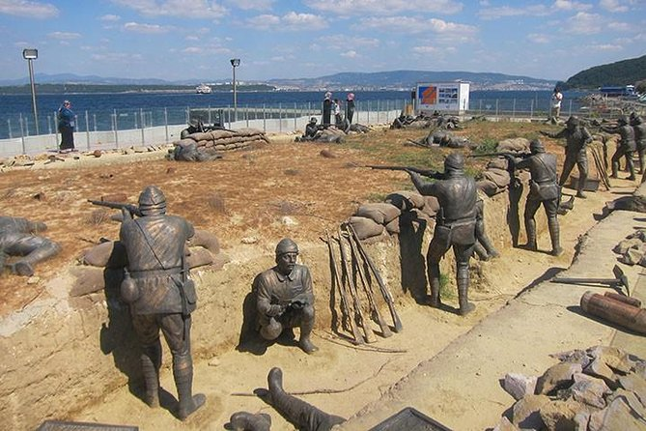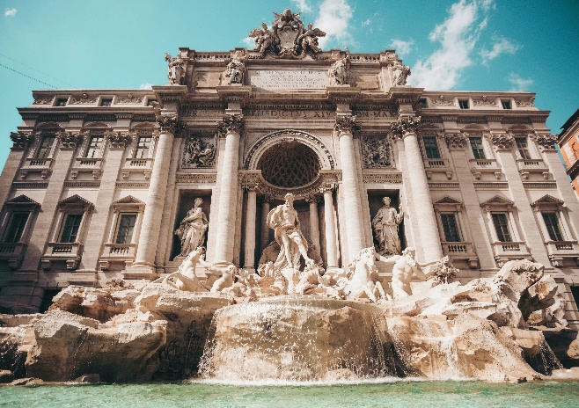
Start visiting the fields with Ariburnu Cemetery and Anzac Cove because these are the places where the war had started. Then Beach Cemetery, Lone Pine and Chunuck Bair. After the tour we will drive you to the hotel. Overnight in Canakkale.
Day 4 - Troy Tour - Pergamon – Kusadasi
(Breakfast, Lunch and Dinner included)
We depart at 08:30 and driving 30 minutes for to Troy. Visit the famous archeological and mythological site of Troy, home of the Trojan Horse and Helen of Troy. After Troy tour, 3hour drive to Pergamon. Lunch break around 13:00 pm. and after the lunch departure for tour of the magnificent Bergama Museum. It is an impressive Museum and you may see many important relics from Ancient Pergamon. Pergamon is a famous city for its jewellery, stones and silver. So on the way, we will visit a jewellery center for 30 minutes. Arrival to Kusadasi around 18:00 pm. Dinner and Overnight in Kusadasi.
Day 5 - Kusadasi - Ephesus Tour - Turkish Village Sirince
(Breakfast, Lunch and Dinner included)
After breakfast between 08:30 am, departure from hotel fully guided tour of Ephesus, one of the best-preserved ancient sites in the world en - route, visiting the Temple of Artemis, Curetes street, famous Roman baths, Celsus Library and
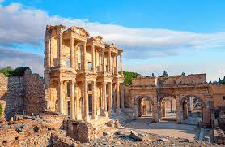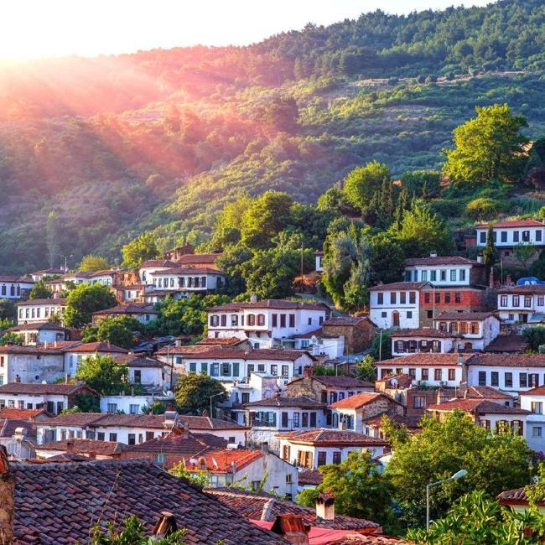
Grand theatre. Lunch break around 13:00 pm.
After the lunch, we will visit a place, which continues to perform one of the oldest arts of Turkey; a carpet-weaving centre. After lunch, we will do a Turkish Village Tour. Sirince’s construction style today belongs to Anatolian Greeks. The houses on the slope are all Orginal with their white paints. Sirince Village also has a fantastic reputation for making some of the best wines in Turkey - especially fruit wines. There will be some free time to explore around of the village. On the way, we will visit one of the famous leather production centers of the region, where you will have the opportunity to get a good factory rate. On this guided tour, you will avoid the constant nagging and sometimes bullying that is well known in the markets of Turkey. Enabling you to enjoy the shopping experience whilst gaining the knowledge of the ancient craftsmen. Dinner and Overnight in Kusadasi.
Day 6 - Kusadasi - Pamukkale Tour
(Breakfast, Lunch and Dinner included)
We depart for Pamukkale at 08:00 am. Upon arrival to Pamukkale we have a lunch break until 13:30 pm. Afterwards we shall visit the calcium terraces of Pamukkale (cotton castle) and the ruins of Hierapolis, then walk around this natural phenomenon and have the option of lying in the waters of the natural springs. Denizli/Pamukkale means seaside in Turkish and is located on the Buyuk Menderes River. It is a growing industrial town, known for its textile industry and outlet shopping. You will visit one of the famous textile factories of Pamukkale. Dinner and Overnight in Pamukkale.
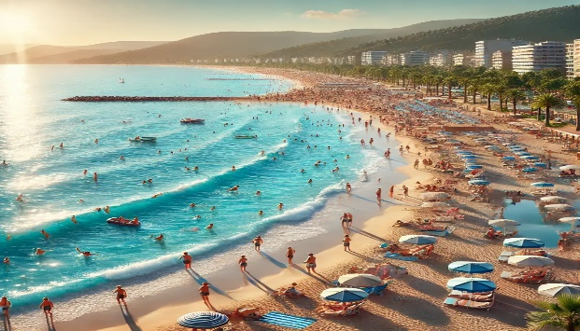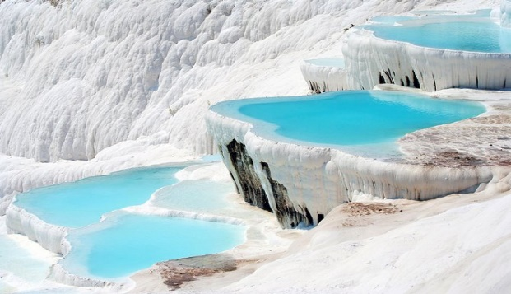
Day 7 - Pamukkale to Antalya
(Breakfast and Dinner included).
After breakfast, at 10:00 am. we depart for Antalya. The trip is going to take roughly 3 to 4 hours. Once you reach Antalya, check in to your hotel and rest of time is yours. Dinner and Overnight in Antalya
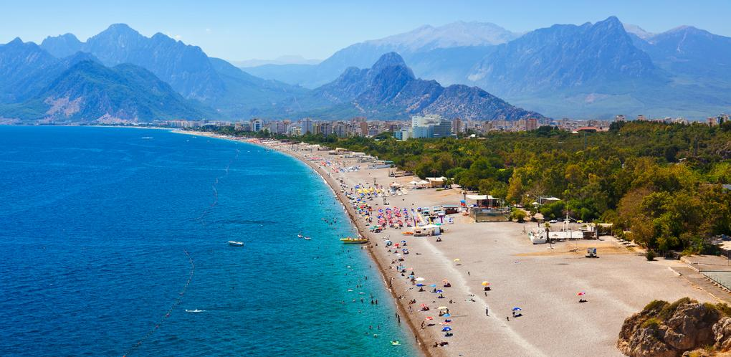
Day 8 - Antalya Old City Tour and Waterfalls
(Breakfast, Lunch and Dinner included)
After breakfast drive to Antalya Old City ( Kaleiçi ) Marina, Clock Tower, Hadrian's Gate, Broken Minaret, Hıdırlık Tower: Kaleici is a small historic part of Antalyas modern city, also known as the Old City of Antalya. In history it was once the sprawling modern Roman town, then the Byzantine Empire, then Seljuks, and finally the Ottoman Turkish town. The Hadrian's Gate (or Hadrianus Gate or The Three Gates is a triumphal arch which was built in the name of the Roman emperor Hadrian. Antalya's broken wonder is the Broken Minaret of the Korkut Mosque, which itself was built originally as
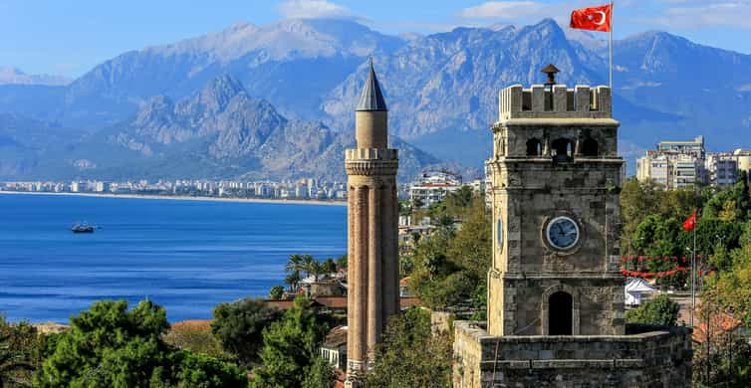
a Roman temple in the 2nd century AD, and thus did not have a minaret at all. Hıdırlık Tower is a landmark tower of tawny stone in Antalya, Turkey, where Kaleiçi meets Karaalioglu Park. It is believed to be built in Hellenistic era on a square plan and later turned into circular tower in 2nd century AD and was used as either a fortification or a lighthouse in the past. We have lunch at the hotel and than depart for Duden Waterfalls. All the streams of the region aim at finding their way into the Mediterranean and they pour down the slopes of the Taurus, sometimes overland sometimes underground and reaching their destination, result in lovely waterfalls, of which there are more than twenty. After tour come back to hotel and rest of day is yours. Dinner and Overnight in Antalya.
Day 9 - Antalya to Istanbul - End of Tour
(Breakfast included)
Today we depart for Antalya airport for our domestic flight to Istanbul and then back to home. We hope your tour was a memorable one and we would like to see you in the future in one of our tours again. Have a nice trip back home and thanks for choosing Turkey.

TOUR ENDS

