Nepal Tourism

Nepal, nestled in the Himalayas between India and China, is renowned for its stunning natural landscapes, including Mount Everest, the world's highest peak. It is a country rich in cultural diversity, with a vibrant mix of ethnic groups, languages, and traditions. Nepal is also home to significant religious sites, such as Lumbini, the birthplace of Lord Buddha. With its breathtaking scenery, rich cultural heritage, and opportunities for adventure tourism, Nepal is a captivating destination for travelers.
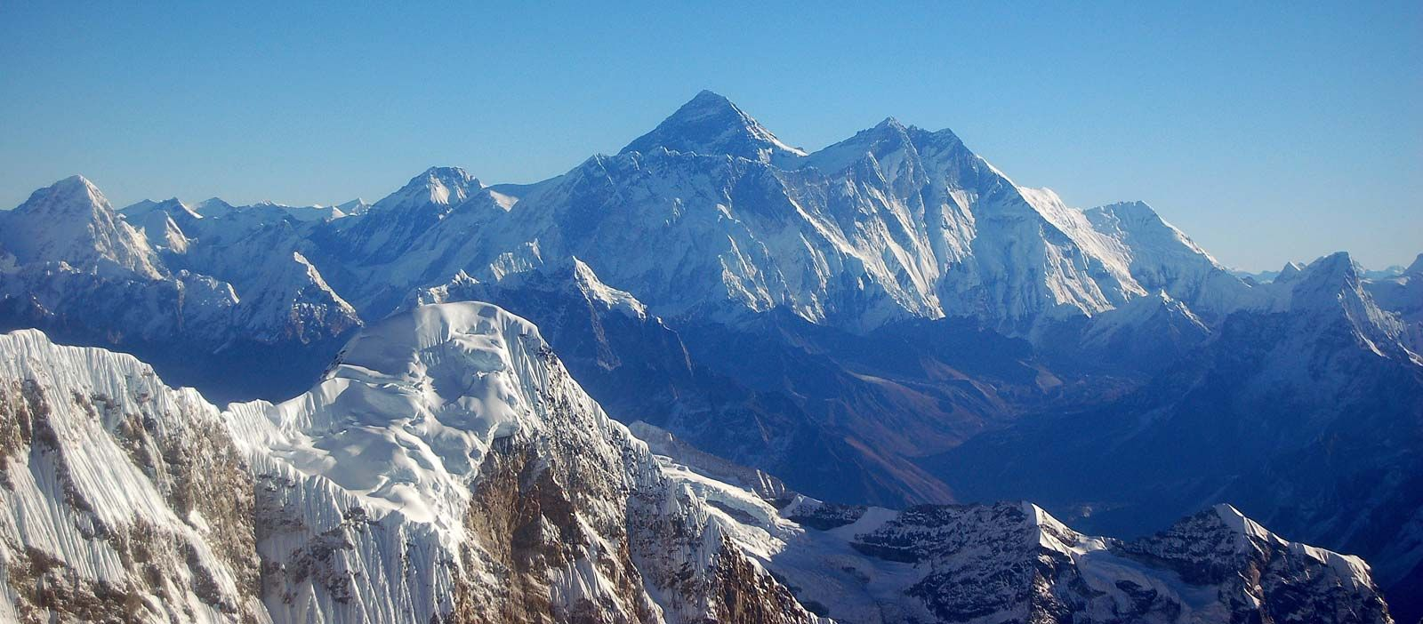

Population: 30 million people. Ethnic Groups: Brahmins, Chhetris, Newars, Tharus, Gurungs, Tamangs,

Capital City: Kathmandu. CURRENCY: The Nepalese Rupee: Indian Rupee 1 INR = 1.6 NPR.
Tourism Highlights
Mount Everest: Trekking and mountaineering draw adventurers worldwide.
Heritage Sites: Kathmandu Valley's UNESCO sites like Swayambhunath, Pashupatinath, Bhaktapur Durbar Square.
Wildlife: Chitwan National Park and Sagarmatha National Park offer unique biodiversity.
Adventure Activities: Trekking, paragliding, river rafting, and scenic mountain flights.

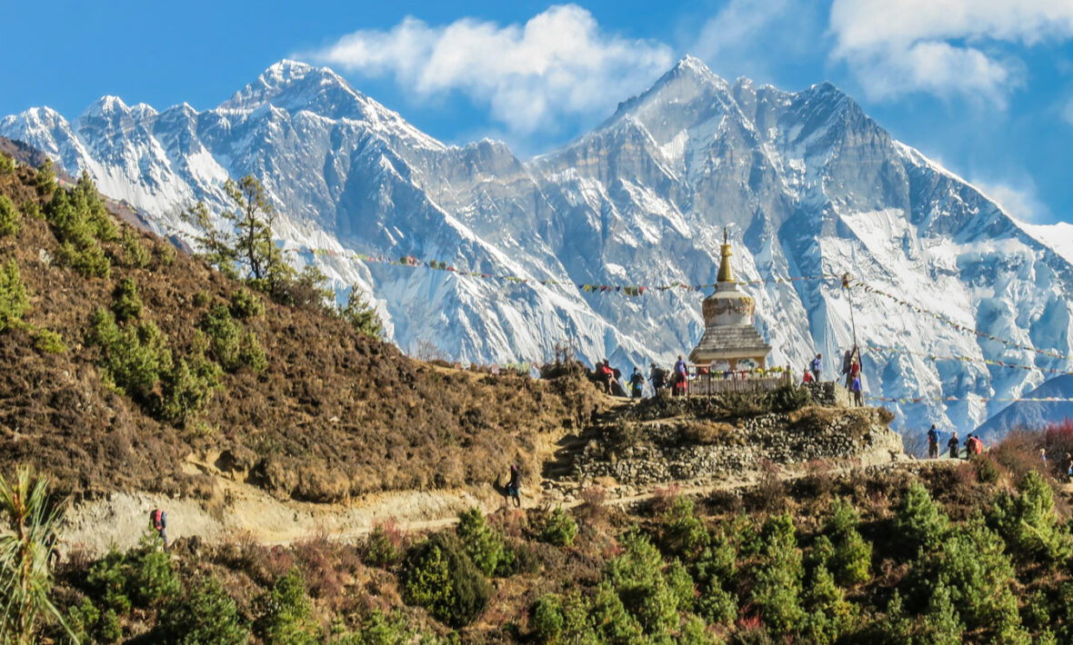

Nepal tourism includes a memorable journey to a vast array of temples, most common among them being the Pashupatinath temple, the world’s largest Shiva shrine. Tourism in Nepal also revolves around magnificent jungle safaris, paragliding, bird watching, canoeing, kayaking, boating, fishing, mountain flights and biking and so on.

Kathmandu City: The largest city and capital and blessed with ancient palaces and temples as well as offers a wide range of adventures: trekking, rafting, jungle adventures and other extreme sports. Devotees throng the Pashupatinath Temple every year, which is another attraction of Kahtmandu.

Mount Everest, the world's highest peak, is a majestic mountain in the Himalayas, attracting climbers and adventurers from around the globe.

Phewa Lake: This enviably beautiful lake is the centre of attraction in Pokhra. Offering the perfect natural retreat to the tourists, it is classified as seminatural freshwater lake.

Mahendra Gupha (cave): One of the nature's wonders in Nepal is the Mahendra Gupha. If you are planning
to visit the cave, don't forget to carry a torch to see the stalactites and stalagmites.

Devi’s Fall: Located in Pokhra, this breathtakingly picturesque lake is locally known as 'Pataley Chhango'.

Lumbini: Well-known as the sacred birthplace of Lord Buddha, Lumbini offers a vast array of monuments and temples.

Trekking in Pokhra: Want to experience the pleasure of being alive, then set yourself to a trekking expedition in Pokhra and witness the wild and lofty places of Nepal that only a few would dare to attempt.

When to visit: Nepal can be visited at any time of the year. However, dry and warm seasons, March-June and September-November, are best for trekking and other adventurous activities and therefore the peak months in Nepal tourism

Nepal
Kathmandu - Pokhara

(5 Nights 6 Days)

Day 01 Arrival Kathmandu Meeting and assistance by our representative.
Transfer to hotel (Normal check-in time of hotel is 1400 hours) Overnight at hotel in Kathmandu.

Day 02 Early morning transfer to airport for Mountain Flight (Subject to weather condition).
After Mountain flight back to the hotel for Breakfast.

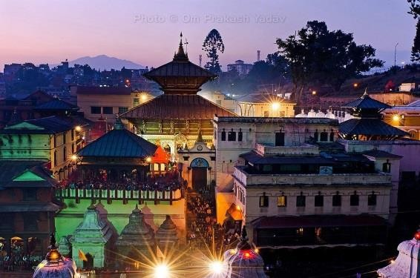
Overnight at hotel in Kathmandu
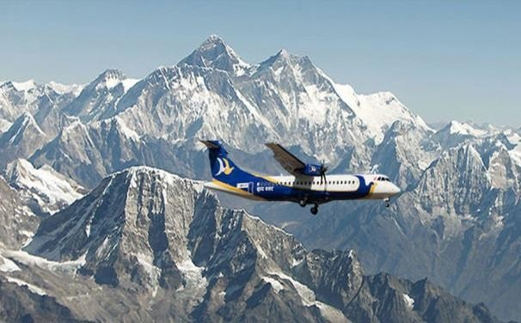
AM : Half day sightseeing tour of Pashupatinath + Boudhnath

PM : Half day sightseeing tour of Kathmandu Durbar Square + Swayambunath
Mountian Flight -In Nepal, seeing the remote corners of the Himalayas need not be a problem. Mountain flights provide the answer. In just a short time, you will be experiencing the Himalayas at such close range it will seem as though you could reach out and touch them. The mountain flight gives the best opportunity to get the closest and the best view of Mount Everest (8,850mts) & other mountains such as; Shisa Pangma (8,013m), Gauri Shanker (7,134m), Melungtse (7,023m), Cho Oyu (8,201m), Pumori (8,171m), Nuptse (7,855m), Lhotse (8,516m) & Amadablam (6,856m). The flights are operated every morning from Kathmandu airport which fly at an average altitude of 6,500 - 7,000 meters. Circling Mount Amadabalm to enter the Khumbu valley, Mt.Flight take the passengers almost five nautical miles from the highest peak in the world - Mt. Everest (weather permitting). This flight usually lasts for about 45 minutes.

Kathmandu City - known as Kantipur, the capital of the Kingdom of Nepal. Here you will visit the temple of the Living Goddess, who acknowledges the greetings of the devotees from the balcony of her temple residence. Kasthamandap - the source of the name Kathmandu and supposed to be made from the timber of a single tree and the Durbar Square are with it's array of temples overlooked by the Hanuman Dhoka Palace, the ancient place of the Nepalese Royalty.

Swayambhunath - located approximately 4 km/2.5 miles, Buddhist stupa this is said to be 2000 years old. The stupa which forms the main tructure is composed of a solid hemisphere of brick and earth supporting a lofty conical spire capped by a pinnacle of copper gilt. Painted on the four sided base of the spire are the all seeing eyes of Buddha. This hill is a mosaic of small Chaityas and Pagoda temples.
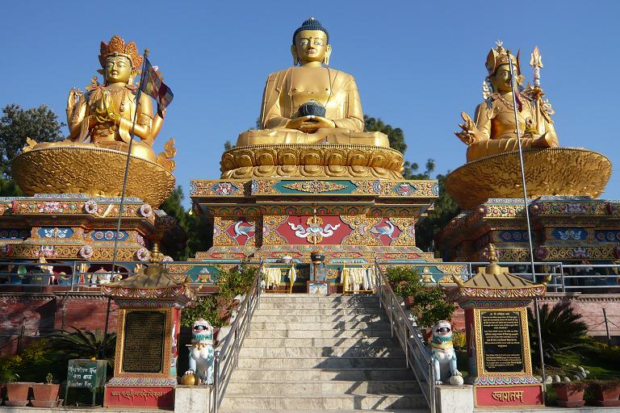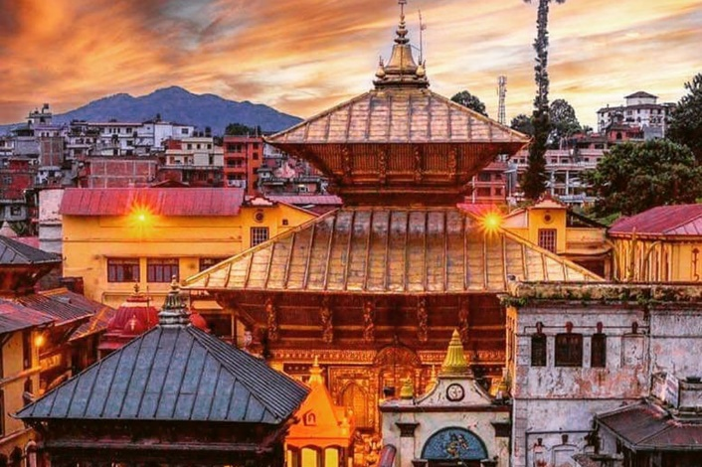
Pashupatinath - situated 5 km east of Kathmandu city, Pashupatinath temple is one of the holiest Hindu temple dedicated to Lord Shiva. Situated, amidst a lush green natural setting on the bank of the sacred Bagmati river, the temple built in pagoda style has gilted roof and richly carved silver doors. Visitors will be permitted to view the temple from the east bank of River Bagmati, entrance in the temple being strictly forbidden to all non-
Hindus. Pashupatinath is the centre of annual pilgrimage on the day of Shivaratri which falls in the month of February/March. Behind the temples are the cremation grounds.

Bodhnath - this stupa, eight kilometres east of Kathmandu City is one of the biggest in the world of its kind. It stand with four pairs of eyes in the four cardinal direction keeping watch for righteous behaviour and human prosperity. This Buddhist stupa was built by King Man Deva at the advice of Goddess Mani Jogini. It is built on an octagonal base inset with prayer wheels. The shrine is ringed by houses of Lamas or Buddhist priests.

Day 03 Breakfast at hotel

Drive to Pokhara which takes approx. 06 to 07 hours drive under normal road condition.

Overnight at Hotel in Pokhara

Day 04 Early morning drive to Sarangkot for Sunrise view & Mountain view (Subject to weather condition) Back to Hotel for breakfast.
Full day sightseeing tour of Pokhara City includes Bindyabasani Temple, Seti Gorge, Devi's fall, Gupteshwor Mahadev Cave, Peace Stupa + One hour boat ride on Phewa Lake

Overnight at hotel in Pokhara

Sarangkot - The view of the Annapurna Himalaya from Sarangkot is almost a religious experience. From here, you can see a panoramic sweep of Himalayan peaks, from Dhaulagiri (8167m) in the west to the perfect pyramid of Machhapuchhare (6997m) and the rounded peak of Annapurna II (7937m) in the east. At dawn and dusk, the sun picks out the peaks in brilliant colours.
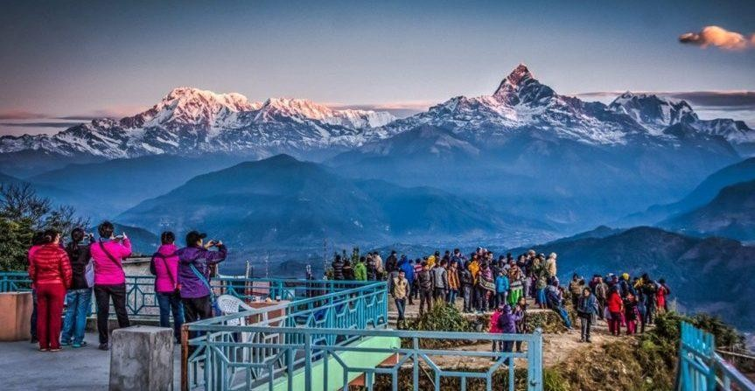

Bindyabasini Temple - it is located on the top of a small hill at the north end of the old bazaar. This is believed as one of the oldest temples in the valley, and is most famous in Pokhara Seti gorge - it is mysterious wonder of Pokhara, originated from the Machhapuchare glacier. Seti (which means white in Nepali) river runs through the main city area in about 40 meters depth. The river provides a perfect view of its dreadful rush before it disappears at Bagar into a deep gorge. The gorge is visible from the bridges in the city.

Devi's Fall - the water flowing from Phewa Lake shows a wonderful fall. We find hollow sandy part and a heavy fall of water within its natural trench. It looks really amazing scene of rainbow with sunlight when a volume of water falls in the deep rocky gorge and produces the water vapour especially in summer.

Gupteshow Mahadev Cave is a sacred cave in Pokhara, Nepal, known for its Shiva temple and stunning natural formations.

World Peace Pagoda – it is a massive Buddhist stupa located on a hill top (Rani Ban) just behind Phewa Lake. This stupa is symbol of peace where the huge idols of Lord Buddha from Japan, Srilanka and Thailand have been installed. From here one can enjoys the breathtaking views of imalayan Ranges, lakes and the city.

Day 05 Breakfast at hotel Drive back to Kathmandu.

Overnight at hotel in Kathmandu.

Day 06 Breakfast at hotel

Free till departure (Normal check-out time of hotel is 1200 hours) Transfer to international airport for onward journey

TOUR ENDS

