Maldives Tourism
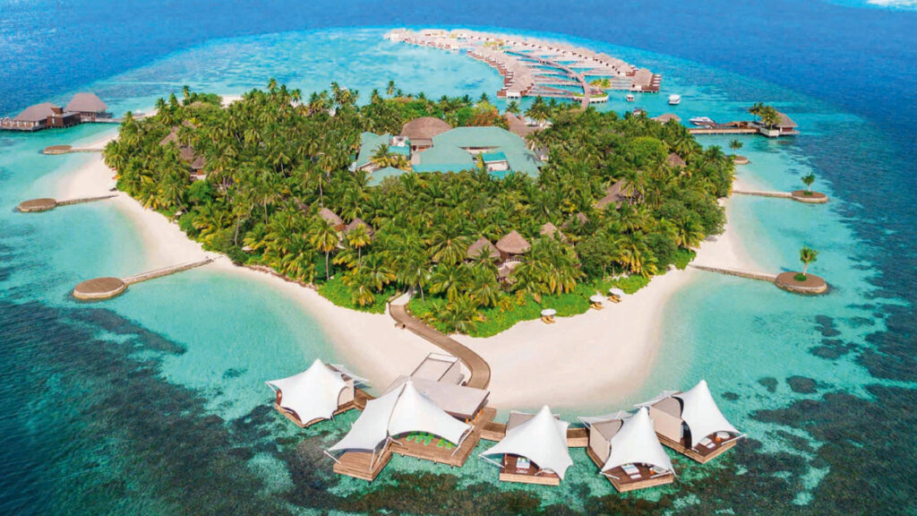
The Maldives, located in the Indian Ocean, is a tropical paradise known for its stunning white-sand beaches, crystal-clear turquoise waters, and luxurious overwater resorts. Comprising over 1,000 coral islands, it offers world-class diving, snorkeling, and marine life experiences. With its serene beauty, vibrant marine ecosystems, and tranquil ambiance, the Maldives is a sought-after destination for honeymooners, beach lovers, and adventurers.
Key Facts: Southwest of Sri Lanka, straddling the equator. Latitudes 4 degrees 17 north and longitudes 73 degrees 50 east. Geography: 1,190 coral islands forming an archipelago of 26 major atolls. Stretches 820 kilometers from north to south and 120 kilometers from east to west. 202 islands are inhabited, 107 are private resort islands.
Climate: Generally warm and humid with year-round sunshine. Average temperature is around 29 - 32 degrees Celsius, rarely colder than 25 degrees Celsius.
What to wear: Dress is generally casual. T-shirts and cotton clothing are most suitable. In Male’, the capital island, and other inhabited islands it is recommended that women respect local customs and wear modest clothing.
Population: Approx. 298,968. Language: Dhivehi - English is widely
Economy: Tourism is the main industry, Currency: The Maldivian currency Rufiyaa 1 MVR = 5.48 INR
Time Difference: India is 30 Mn’s Ahead Must Eat Food : Garudhiya is a flavorful fish soup, Mas Huni is shredded smoked tuna mixed with spices, and Roshi is a thin flatbread often eaten with curries or as a wrap
MALDIVES Tourism
(4 Nights 5 days)
Day1 : Arrival in the tropical paradise of Maldives. Get transferred by speedboat to your resort and check in to your room, spend the day relaxing and enjoying the views of crystal clear waters ebbing sandy beaches.
Overnight at Hotel
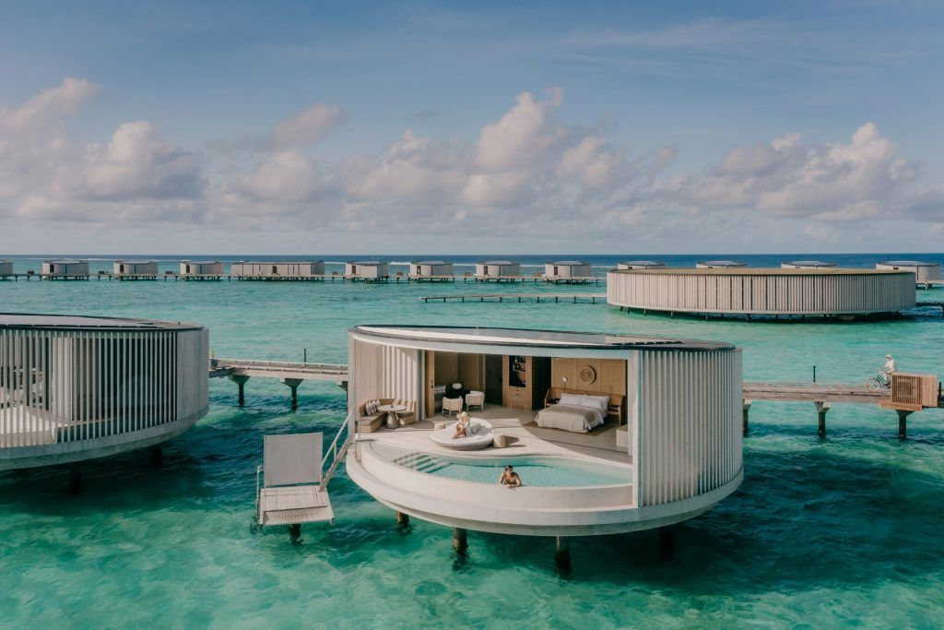
Day 2 ( at leisure | Optional Water sports)
After a tasty breakfast today, we recommend many options for you. You can choose to soak in the sun on the beach, go for a swim or do absolutely nothing! If adventure is what you like, opt for some water sports like snorkeling, wind surfing or have fun on a banana boat ride.
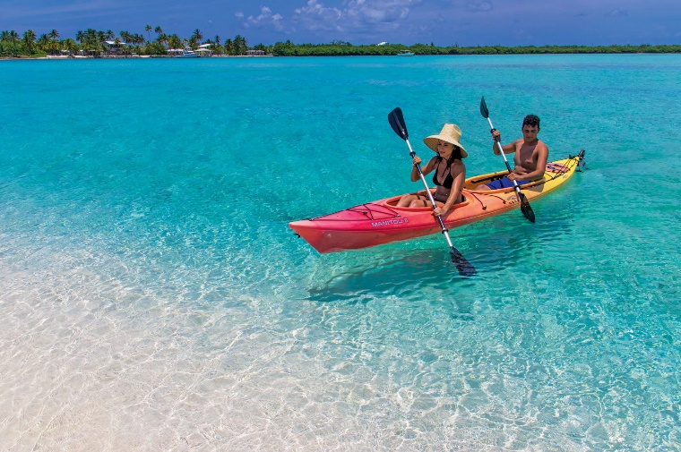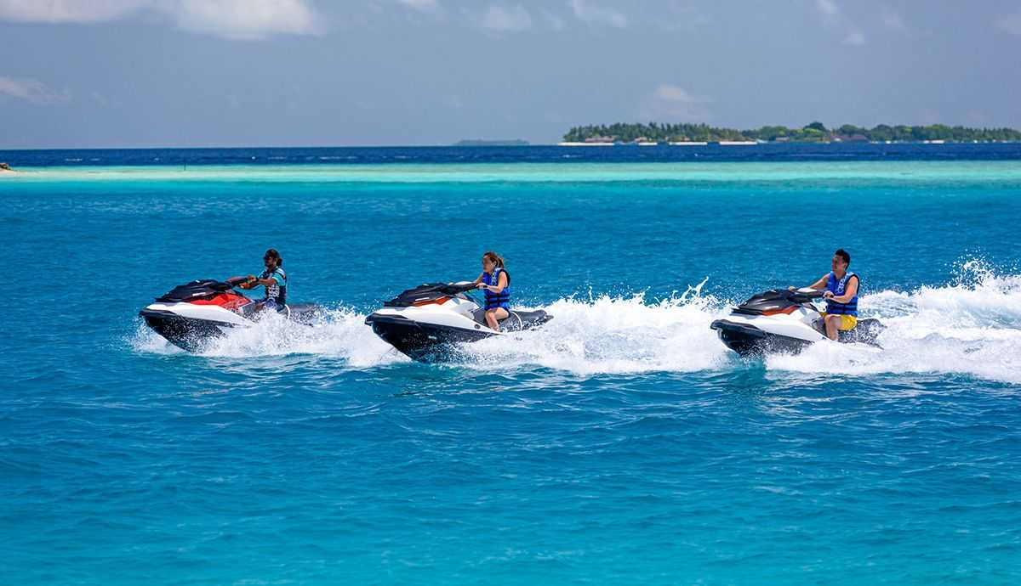
Overnight at Hotel (Breakfast + Lunch + Dinner)
DAY 3 Day at Leisure | Optional Spa and Wellness Therapies
After a scrumptious breakfast today, we recommend you pamper yourself with an indulgent spa treatment. Choose from a relaxing aroma therapy treatment or a rejuvenating body spa wellness package
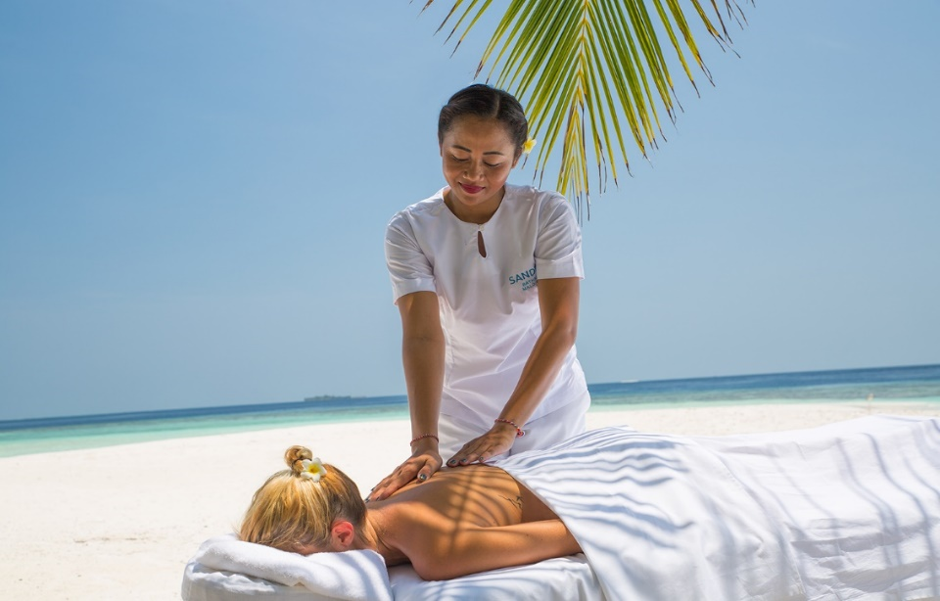

Day 4 Day at Leisure |
After your Breakfast , ( at leisure | Optional Water sports Ref Attachment.
(Breakfast + Lunch + Dinner)
DAY 5
After a scrumptious breakfast today, Transfers to Male city for your onward journey with memories.

Tour Ends

