Kazakhstan Tourism

Kazakhstan is a unique region in the world because of its history, geographical position, and size. Being the world’s 9th largest country and located in the center of Eurasia,

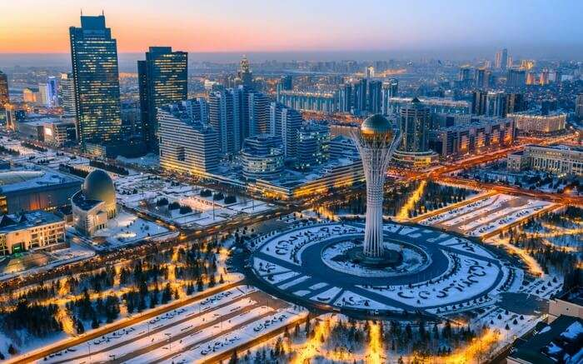

The diversity of Kazakhstan's natural areas has contributed to its rich flora and fauna. The country is a habitat for about 122 mammal species, 500 bird species, and 107 fish species; in addition, over six thousand species of plants grow in the region. The most famous of them among tourists include Aksu Zhabagly Nature Reserve, which is home to snow leopards and other rare animals Korgalzhyn Nature Reserve is famous for its pink flamingos and other rare species of wildlife and is popular among bird-watchers

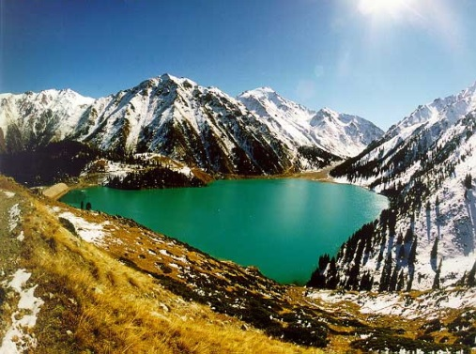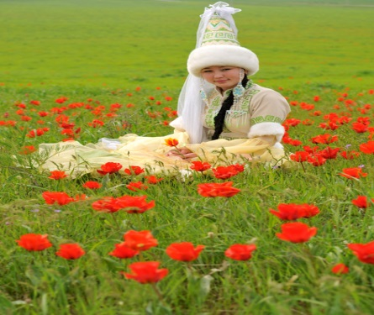

Mountains: Trekking and winter sports : A series of mountain ranges of various sizes – such as the Tien Shan, Altay, Ulytau, and Kazygurt – are naturally beautiful and attract tourists from all over the world. The Tien Shan Mountains are the highest among them (with the highest peak being about 7,500 metres [24,500 feet]), and Almaty, the largest city of Kazakhstan, is located at its base.

Kazakhstan is more than its steppes and mountains; it is also a country of rivers and lakes. A lake among the steppes can be like an oasis among empty deserts.

Quick facts about Kazakhstan Capital: Astana Largest cities: Almaty,

Languages: Kazakh and Russian Currency: 1 Tenge (KZT)= 0.17 Paisa INR

Time Difference: India is 30 Mn’s Ahead of Kazakh Visa: Visa Free for Indians upto 14 days

Weather: Best season March to November, since winter in Kazakhstan is usually cold; however snowy winters might be perfect for winter sports. Temperature in summer can reach up to +40'C and more in some regions.

Population: major ethnicity is Kazakh; other ethnic groups include Russians, Uzbeks, Tatars, Germans, etc.

Food: Kazakh cuisine, Central Asian, Russian cuisines, as well as Italian, Turkish, Korean restaurants are popular in Kazakhstan.

ALMATY
( 5 Nights 6 Days)

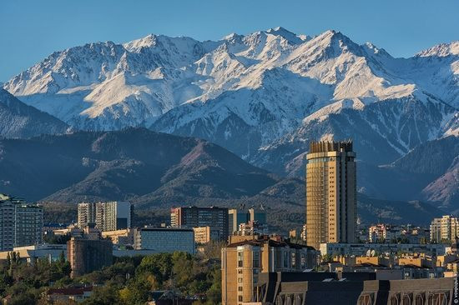

DAY 1 INDIA - ALMATY- WELCOMES YOU!

- Arrival in Almaty at 16:35 PM (KC 908 DEL-ALA 16:35 PM)
- Transfer Airport-Hotel by bus/ Check-in to the Hotel at 19:30 PM
- dinner at indian restaurant
- Transfer to Hotel at 10:30 PM
- Free time – can explore night Life activities at you own.
- Overnight at Hotel.

DAY 2 WELCOME ALMATY CITY TOUR
-Breakfast 07:00-10:00AM
-10:30 AM Almaty city Tour with English speaking guide
You will know more about history and development of the southern capital of Kazakhstan and see its major attractions:, Palace of President, Republic Square and Monument of Independence, and Astana Square, Panfilov Park, Abai Square and Palace of Republic, Presidential Park.
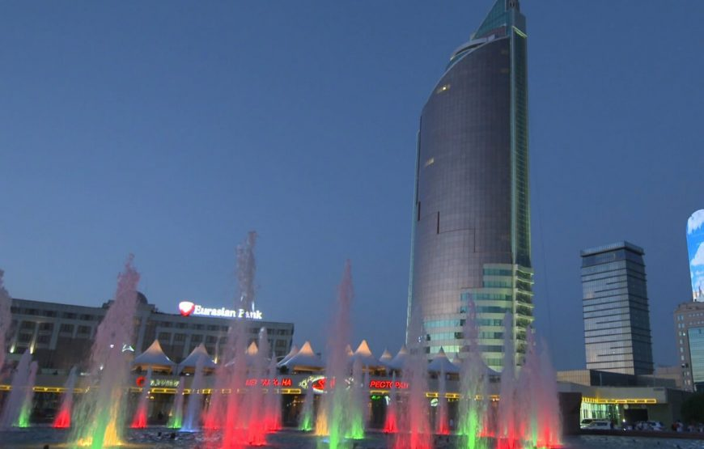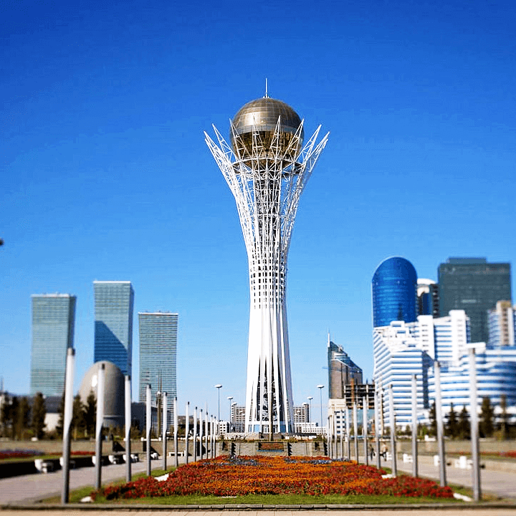
- Lunch in Indian Restaurant at 13:00
- 14:30 PM Continue Almaty City Tour, Rakhat Chocolate Factory shop and Local Market Zilyoni -Bazar.
You can buy Chocolates from Rakhat Chocolate Factory shop; can buy Dry Fruits at cheap rates and some souvenirs from Zilyoni Bazar.
- Transfer to the hotel at 18:00
- Time to Relax a bit after long walk.
- Transfer for Dinner at Indian Restaurant at 20:30 PM
- Transfer Back to Hotel at 10:30 PM
- Free time – can explore night activities at you own
- Overnight in hotel

DAY 3 ALMATY- MEDOWS & CHIMBULAK
Breakfast 07:00-10:00AM & Transfer to excursion at 10:30 AM
This tour provides you the best opportunity to see the beautiful mountain surroundings of Almaty city. The first stop of the tour awaits you in the Medeo Gorge, where in the wonderful mountains of Trans-Ili Ala-Tau the largest high mountain skating rink in the world is located as well as the huge dam, protecting the city from destructive mudflows formed on the tops of the western Tien Shan. Next destination is Chimbulak ski resort (Cable Car Fee Included), located at an altitude of 2230 meters above sea level. It is very popular for its mild climate, large quantity of sunny days and snow through the winter and remarkable scenery of mountain ranges.

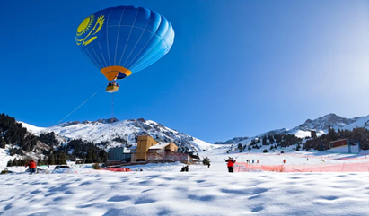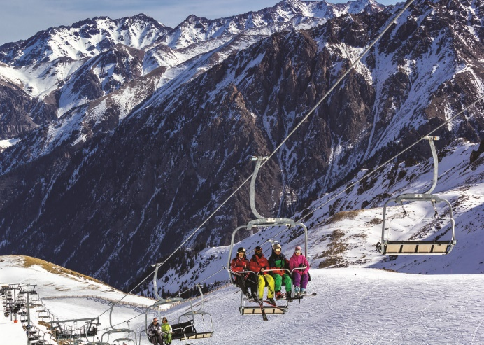
Late lunch at Indian Restaurant & Free time to Look Around!!!!
- Transfer to hotel 17:00 PM
- Free time at your own.
- Transfer for Dinner at Indian Restaurant at 20:30
- Transfer to Hotel at 10:30 PM
- Free time – can explore night activities at you own
- Overnight in hotel

DAY 4 Kok Tobe Tour
- Breakfast 07:00-10:00AM
- 1100 hrs Proceed towards the tour of Kok-Tobe. It is a mountain which is the highest point of Almaty, Kazakhstan's largest city. There is a popular recreation area on top of the mountain. The mountain's height is 1100 meters above sea level. Kok-tobe is one of the main landmarks in the city, and it is popular among visitors and tourists to Almaty.
The Kok-Tobe recreational area has a variety of amusement park type attractions and restaurants. It is connected to downtown Almaty by a cable car line. The City Terminal is located near Hotel Kazakhstan. Also, there is a 372 meters tall TV Tower at the foot of the mountain. The tower can be seen from most parts of the city.

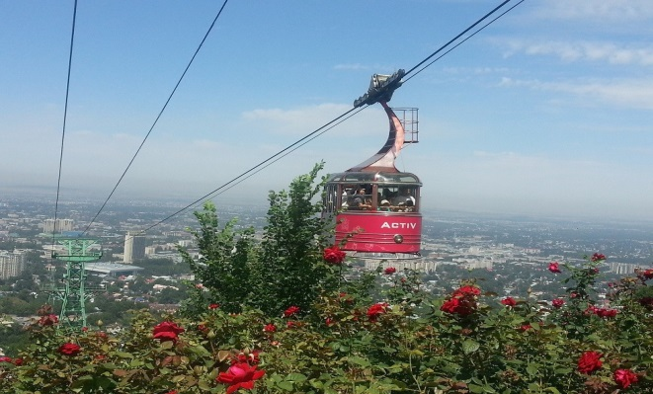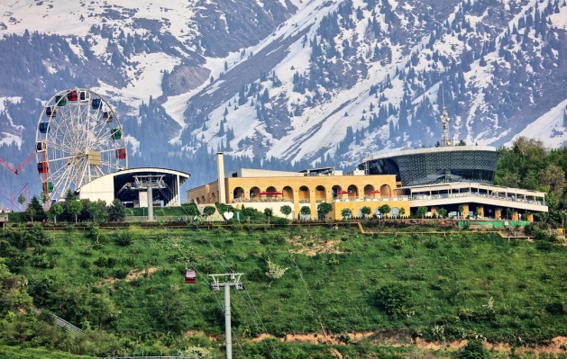
1430 Hrs Transfer to Lunch at Indian restaurant
Free time to explore on your own
-Transfer Back to Hotel at 06:00 PM
- Transfer for Dinner to Indian restaurant at 20:30 PM
- Transfer Back to Hotel at 10:30 PM
- Free time – can explore night activities at you own
- Overnight in hotel
DAY 5 DAY FREE FOR LEISURE ACTIVITIES: Optional: Issyk lake
- Breakfast 07:00-10:00AM

DAY 5 Issyk lake
Issyk-Kul Lake, located in Kyrgyzstan, is one of the largest and deepest alpine lakes in the world, known for its stunning turquoise waters and breathtaking natural beauty. Nestled in the Tian Shan mountains, it is often referred to as the "Pearl of Central Asia" and is a popular destination for outdoor activities and relaxation

- Breakfast 07:00-10:00AM
-1100 hrs transfers to lake
-1500 hrs Lunch at Indian Restaurant
-Free time to explore on your own
-Transfer Back to Hotel at 06:00 PM
- Transfer for Dinner to Indian restaurant at 20:30 PM
- Transfer Back to Hotel at 10:30 PM
- Free time – can explore night activities at you own
- Overnight in hotel

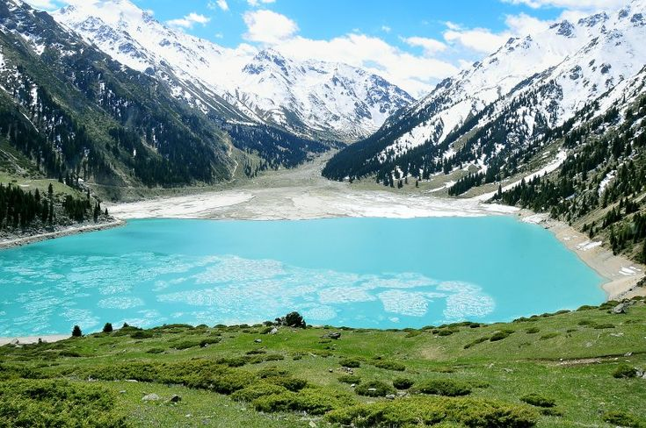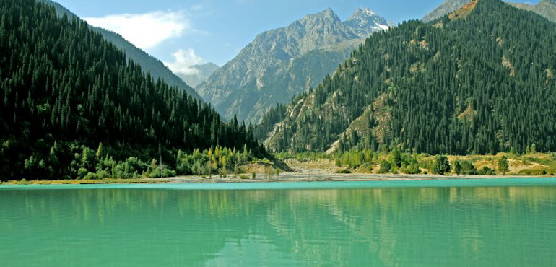

DAY 6 GOOD BYE

Move to the airport for the flight KC907 ||Almaty-Delhi.

Please Note: There might be changes to the above mentioned Itinerary however, smaller might be but it will be aimed to enhance and optimize your experience with us.

International Flight Details: AIR ASTANA Dept KC 907 ALA - DEL 0730 1035

End of Tour

