CHINA TOURSIM
China is the world’s most populous country and the third-largest by area, spanning over 9.6 million square kilometers. It is located in East Asia and has a rich history that stretches back thousands of years, with one of the world’s oldest continuous civilizations. The country has seen significant economic growth in recent decades, becoming the second-largest economy globally, primarily driven by manufacturing, technology, and exports.
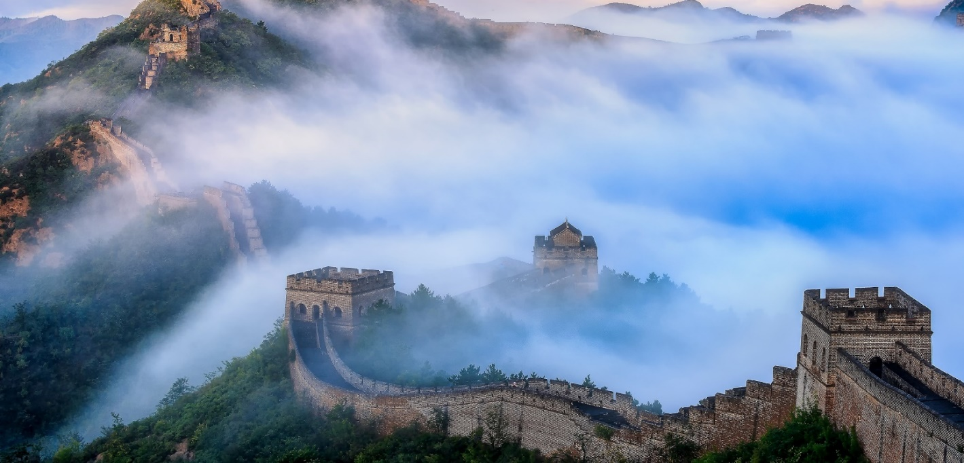
Currency: 1 Chinese Yuan =11.64 Indian Rupees (INR)​ Religion : Buddhism, Taoism, Islam, Protestantism, and Catholicism. Must Eat Food Specialty: Peking Duck, Mapo Tofu, Kung Pao Chicken, and Dim Sum
Languages: Mandarin Cantonese Shanghainese Time difference: China Ahead of India 2.5 Hrs Visa: Mandatory Sticker visa
Tourism Highlights
The Great Wall of China: One of the most iconic landmarks, this ancient structure stretches over 13,000 miles and offers breathtaking views of China's northern countryside.
Forbidden City (Beijing): A UNESCO World Heritage site, the Forbidden City is a massive imperial palace complex, representing China's historical and cultural grandeur.
Terracotta Army (Xi'an): Thousands of life-sized clay soldiers and horses, created to protect China's first emperor, are one of the most significant archaeological discoveries in history.
Li River (Guilin): Known for its dramatic karst landscape, this river cruise offers stunning views of towering limestone peaks and tranquil waters.
Potala Palace (Lhasa, Tibet): A symbol of Tibetan Buddhism, this majestic palace offers a deep dive into Tibetan history and culture.
Zhangjiajie National Forest Park: Famous for its striking sandstone pillars, this park inspired the floating mountains in the movie Avatar.
Hangzhou (West Lake): Known for its picturesque lake and surrounding scenic beauty, it is also a center of traditional Chinese tea culture.
Shanghai's Bund: A vibrant waterfront area offering a blend of colonial-era architecture and modern skyscrapers.
Jiuzhaigou Valley: A UNESCO World Heritage site, famous for its colorful lakes, waterfalls, and snow-capped peaks, representing the beauty of the Tibetan Plateau.
Mount Everest (Tibet): For adventure seekers, this remote region provides an opportunity to witness the world’s highest peak.

Shanghai and Xitang Water Town
(4 nights 5 days)
Day 1 Arrival in Shanghai : Our guide will meet you at Pudong International Airport and transfer you to the hotel for check in. Enjoy the remainder of the day.
Attractions & Activities: Guide meets you at Shanghai International Airport, then escort to hotel for check-in. Meals: No meal
Day 2 Shanghai : Today, your Shanghai sightseeing will begin with Yuyuan Garden. As a famous classical garden in Shanghai, Yuyuan Garden attracts people by its compact and exquisite layout, and natural features of rocks, pavilions, ornamental ponds and flower walls. You will get refreshed from the outside busy Shanghai at this tranquil and exquisite garden.
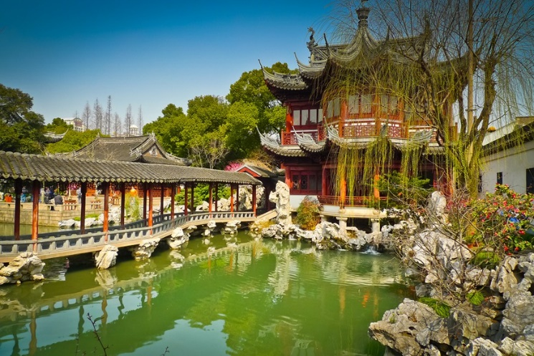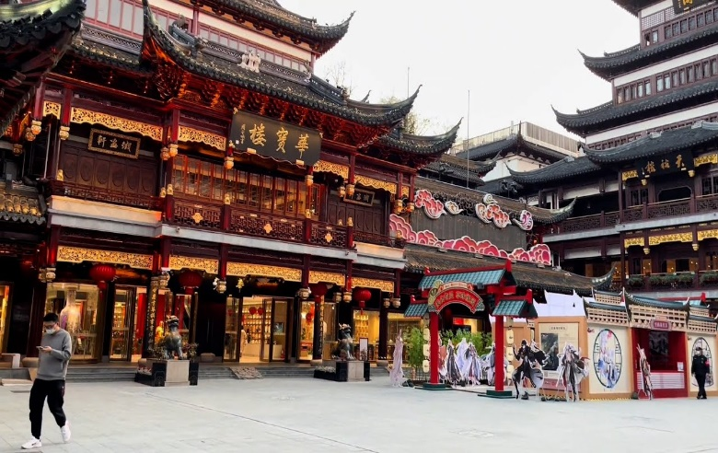
Then we will go to visit Chenghuang Temple. It is a famous Taoist Temple in Shanghai. The Chenghuang Temple attracts people by its unique design and also there are over a hundred stores and shops in this area. Most of these store buildings are nearly a century old.
Free strolling and shopping at Xintiandi will be arranged for the next activity. The Xintiandi is a popular shopping and entertainment center in Shanghai. You will appreciate the modern buildings and architectures of European styles along the street. Also you will find a lot of shops and stores of different styles selling various kinds of commodities.
After that we will have a stop at Former French Concession for some leisure. Then we will go forward the exploration at the Bund. As the most famous sightseeing destination in the city, the Bund has become a symbol of Shanghai and a must-go place for tourists. You will enjoy the fascinating views of Huangpu River and groups of architectures and skyscrapers.
The last attraction to see will be Oriental Pearl Tower. As one of the most important Shanghai landmarks and one of the most attractive places in Shanghai, Oriental Pear Tower appeals people by its unique architectural design and the alluring Shanghai views it brings.
At last, our guide will bring you back to the hotel for a good rest.
Attractions & Activities: Yu Garden, Chenghuang Temple, Xintiandi, Former French Concession, The Bund, The Oriental Pearl Tower
Meals: Hotel Buffet Breakfast, Chinese Lunch
Day 3 Shanghai to Hangzhou : This morning, our guide will transfer you to Hangzhou for the great sightseeing. The first destination to visit in Hangzhou will be the famous West Lake. The West Lake is the most famous attraction in Hangzhou. With its natural beauty and historical sites, you will get a feast of beautiful scenery to the eyes when visiting there.
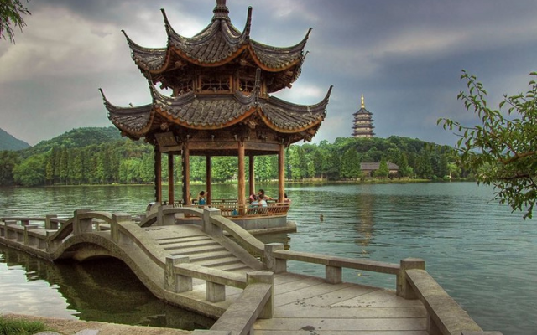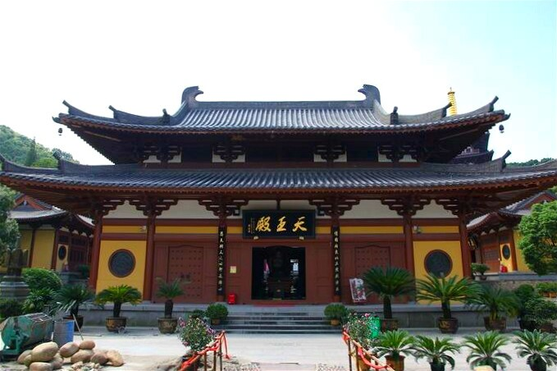
Next our guide will bring you to visit Lingyin Temple. The Lingyin Temple is situated on the west of West Lake. It is a famous ancient Buddhist temple in China. Simple yet magnificent, grandeur but with exquisite structure and delicate carvings, the Lingyin Temple is a masterpiece of ancient architecture. Its quaint architecture tranquil environment, historical sites and cultural relics preserved in Lingyin Temple are what to see there.
Then we will proceed to visit Meijiawu Tea Plantation and you will have time for shopping of the Dragon Well Tea there.
At last, our guide will transfer you to the hotel and help you check in.
Attractions & Activities: West Lake, Lingyin Temple
Meals: Hotel Buffet Breakfast, Chinese Lunch
Day 4 Hangzhou to Wuzhen : After breakfast, our guide will transfer you to Wuzhou for the charming sights of Wuzhen Water Town. With a history more than 2,000 years, Wuzhen Water Town is one of the most famous water towns in Southern Yangtze River with unique natural beauty and profound cultural background. With hundreds of ancient houses built along the river, bridges, flagstones, waterside pavilions, corridors, all these have formed a simple and romantic lifestyle in the town. You will take a boat along the river to fully enjoy its beauty.
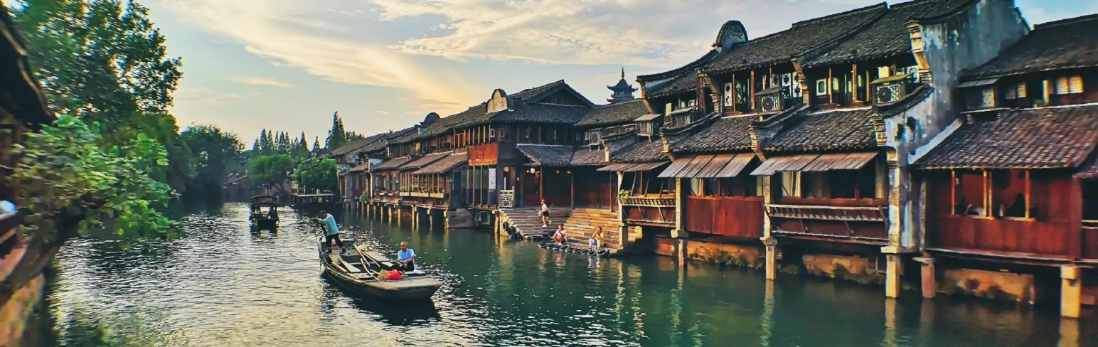
After that we will guide will bring you to the hotel and help you check in.
Attractions & Activities: Ancient Village Wuzhen, The Riverine Ancient Town of Wuzhen, Wu Zhen boat cruise
Meals: Hotel Buffet Breakfast, Chinese Lunch
Day 5 Wuzhen to Shanghai depart : After breakfast, our guide will transfer you back to Shanghai. Then our guide will escort you to the airport and help you board your departure flight. Have a nice trip.

Tour Ends

