CHINA TOURSIM
China is the world’s most populous country and the third-largest by area, spanning over 9.6 million square kilometers. It is located in East Asia and has a rich history that stretches back thousands of years, with one of the world’s oldest continuous civilizations. The country has seen significant economic growth in recent decades, becoming the second-largest economy globally, primarily driven by manufacturing, technology, and exports.

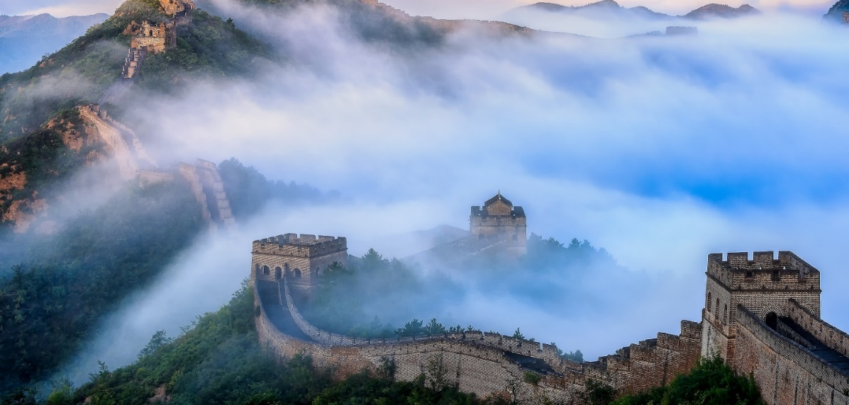
Currency: 1 Chinese Yuan =11.64 Indian Rupees (INR)​ Religion : Buddhism, Taoism, Islam, Protestantism, and Catholicism. Must Eat Food Specialty: Peking Duck, Mapo Tofu, Kung Pao Chicken, and Dim Sum
Languages: Mandarin Cantonese Shanghainese Time difference: China Ahead of India 2.5 Hrs Visa: Mandatory Sticker visa
Tourism Highlights
The Great Wall of China: One of the most iconic landmarks, this ancient structure stretches over 13,000 miles and offers breathtaking views of China's northern countryside.
Forbidden City (Beijing): A UNESCO World Heritage site, the Forbidden City is a massive imperial palace complex, representing China's historical and cultural grandeur.
Terracotta Army (Xi'an): Thousands of life-sized clay soldiers and horses, created to protect China's first emperor, are one of the most significant archaeological discoveries in history.
Li River (Guilin): Known for its dramatic karst landscape, this river cruise offers stunning views of towering limestone peaks and tranquil waters.
Potala Palace (Lhasa, Tibet): A symbol of Tibetan Buddhism, this majestic palace offers a deep dive into Tibetan history and culture.
Zhangjiajie National Forest Park: Famous for its striking sandstone pillars, this park inspired the floating mountains in the movie Avatar.
Hangzhou (West Lake): Known for its picturesque lake and surrounding scenic beauty, it is also a center of traditional Chinese tea culture.
Shanghai's Bund: A vibrant waterfront area offering a blend of colonial-era architecture and modern skyscrapers.
Jiuzhaigou Valley: A UNESCO World Heritage site, famous for its colorful lakes, waterfalls, and snow-capped peaks, representing the beauty of the Tibetan Plateau.
Mount Everest (Tibet): For adventure seekers, this remote region provides an opportunity to witness the world’s highest peak.

Beijing Culture Experience
(5 NIGHTS 6 DAYS)
Day 1 Arrival in Beijing
You will be warmly welcomed by our guide at the arrival hall of the airport. Then our guide will transfer you to the hotel and help you check in.
Day 2 Beijing
After breakfast, our guide will pick you up at the hotel and take you to have an excursion at Mutianyu Great Wall. The Mutianyu Great Wall is located in Huairou District of Beijing and is 73 kilometers from Beijing downtown. It was originally built in Northern Qi Dynasty (550 – 557) and reconstructed in Ming Dynasty to strength its construction. Mutianyu Great Wall is outstandingly featured with dense distribution of watchtowers, with 22 watchtowers at 100 meter intervals. Also these watchtowers have different forms and structures.
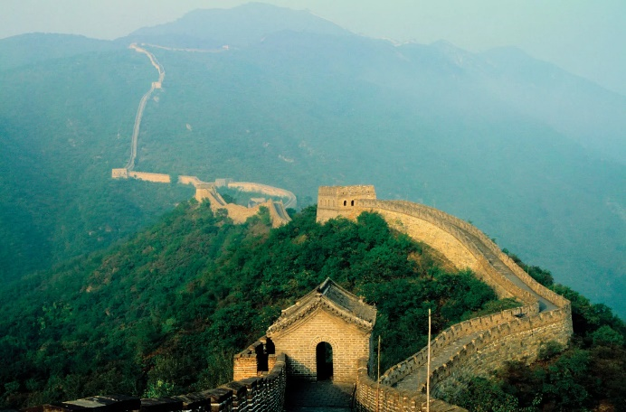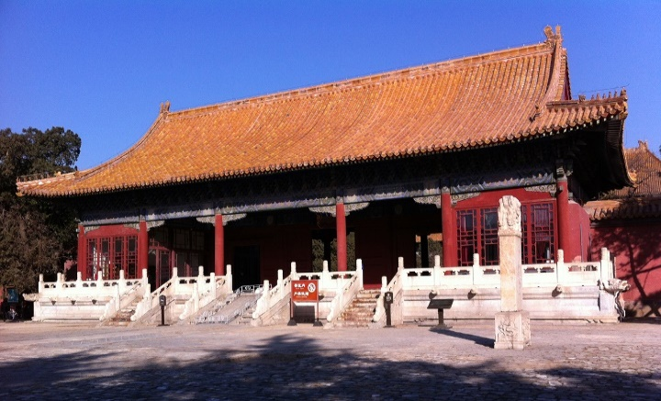
Next our guide will transfer you to visit the Sacred Way inside Changling Tomb. The Sacred Way in Ming Tombs is the best preserved and complete of its kind. This Sacred Way is consisted of stone memorial archway, stele pavilion, stone animal statues, and pillars. Walking along the Sacred Way you will experience the sacred and serene atmosphere.
Then we will proceed to visit Dingling Tomb. The Dingling Tomb is the mausoleum for Emperor Zhu Yijun, the 13th emperor of the Ming Dynasty, as well as his two empresses and one concubine. Dingling Tomb is one of the great three largest tombs among the Thirteen Ming Tombs and is the only one to be excavated. Surrounded by mountains and forest, the Dingling has serene and peaceful environment. With its magnificent buildings and exquisite decorations.
Attractions & Activities: Sacred Way, Dingling Tomb, Mutianyu Great Wall
Meals: Breakfast, Chinese Lunch, Peking Roasted Dinner
Day 3 Today your sightseeing will start with a visit to Tiananmen Square. The Tiananmen Square is the largest public square in the world. It is able to hold over one million people. This famous monument with its historical significance is often considered as a national symbol in China.
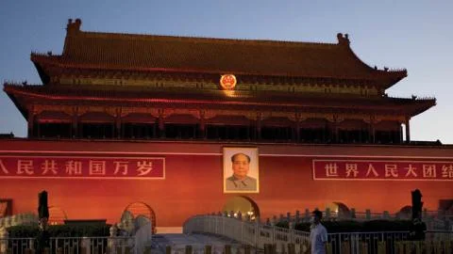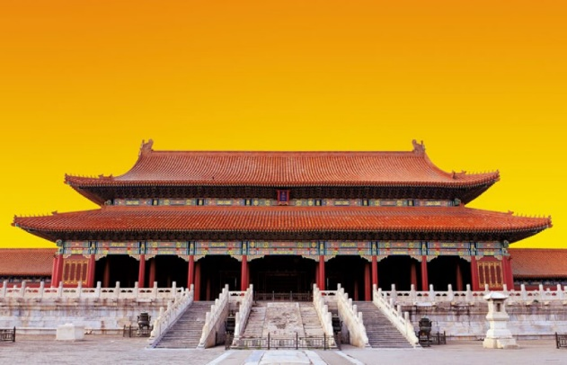
Next we will proceed to visit Forbidden City. The Forbidden City, also called Imperial Museum, was the imperial palace for emperors during the Ming and Qing dynasties. It is the best-preserved imperial palace in China and the largest ancient palatial structure in the world. You will appreciate its magnificence of royal architectures and imperial treasures when visiting the Forbidden City.Then our guide will take you to visit Hutong and Siheyuan so that you will get a deep understanding of Beijing local culture and life
Next scheduled attraction to see will be Yandaixiejie. It is a famous ancient street in Beijing. There are numerous stores and shops lining on both sides of the street selling various kinds of collections of souvenirs and gifts.
The last attraction to see for today will be Drum Tower. The Drum Tower was built in Yuan Dynasty. As it was 46.7 meters high and was placed on brick base, the Drum Tower is a prominent construction in Beijing. As the symbol of old Beijing, Drum Tower is a great site to experience the ancient atmosphere of Beijing.
Tonight, you will enjoy Kungfu Show at Red Theatre. After the show, our guide will bring you to the hotel for a good rest.
Attractions & Activities: Tiananmen Square, The Forbidden City, Hutong, Siheyuan (Ancient Courtyard), Yandaixiejie, Drum Tower Beijing,
Meals: Breakfast, Chinese Lunch

Day 4 Beijing This morning our guide will pick you up and take you to visit Temple of Heaven at first. The Temple of Heaven is a complex of religious buildings situated in the southeastern part of central Beijing, which was visited by the Emperors of the Ming and Qing dynasties for annual ceremonies of prayer to Heaven for good harvest. You will admire its grand size of architectures and profound cultural connotation when visiting the Temple of Heaven.
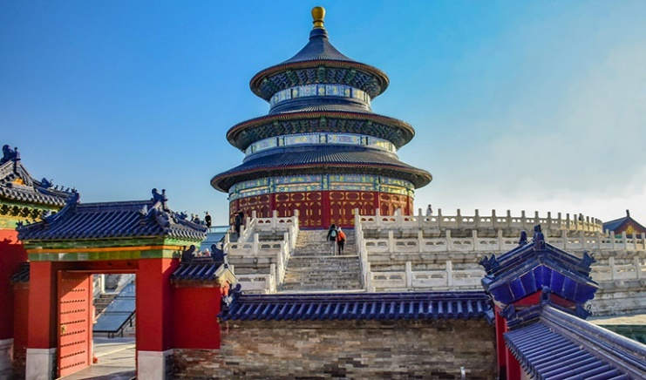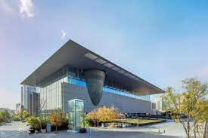
Next we will move on to have a visit to Beijing Capital Museum is a large-scale comprehensive museum. It is an art museum not only lies in its artistic architecture that integrates classical and modern beauty, but more importantly in its collections of artworks. The Capital Museum has a collection of more than 200,000 cultural relics, including ancient porcelain, bronze, calligraphy, painting, jade, sculpture, Buddhist statues and many other items. You will appreciate exquisite artworks and get a better understanding of Chinese history and culture by visiting this museum.
The next scheduled site to visit will be Lama Temple. Also known as Yonghe Lamasery, Lama Temple is a temple and monastery of the Geluk School of Tibetan Buddhism located in Dongcheng District of Beijing. Applied a combination of traditional Chinese, Tibetan, Mongolian and other ethnic styles in its architectural arts and decorations, the Lama Temple is a hot destination to admire its magnificent buildings and the religious relics.
The last arranged site to visit will be Beijing Zoo. There are around 450 different species of animals to see at Beijing Zoo. Also the Panda House inside the zoo is a great place to see the cutest pandas.
Afterwards, our guide will transfer you back to the hotel.
Attractions & Activities: Temple of Heaven, Beijing Capital Museum, Lama Temple, Beijing Zoo
Meals: breakfast, Chinese lunch
Day 5 Beijing
Today your trip will start from 798 Art District. The 798 Art District is a leading community of contemporary art galleries in Beijing. You will discover unique Chinese modern culture and art at those specialized art shops and exhibitions there.
Next we will continue our trip to visit Summer Palace. The Summer Palace is the largest imperial park in China. It has a vast collection of lakes, gardens and palaces and you will appreciate its natural beauty and numerous historical sites.
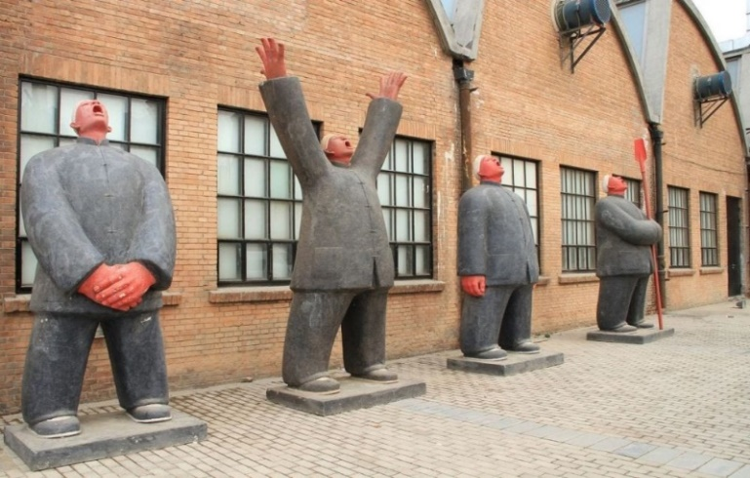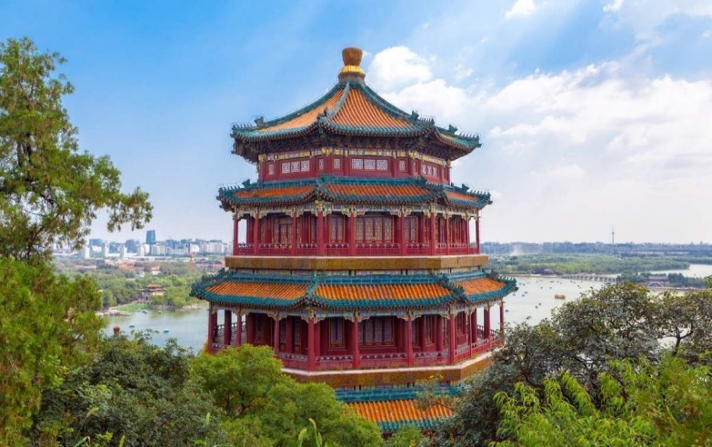
Afterwards, our guide will bring you to see the Beijing Olympic Stadium for its unique modern design and humanistic architecture.
At last, our guide will transfer you back to the hotel.
Attractions & Activities: 798 Art District, Beijing Olympic Stadium, Summer Palace
Meals: Breakfast, Chinese Lunch
Day 6 Departure from Beijing
Feel free for leisure after breakfast. Our guide will escort you to the airport on time and help you board your departure flight. Have a nice trip! Attractions & Activities: Transfer you to airport to take flight to your next station.
Meals: Breakfast.
Tour Ends

