BHUTHAN TOURSIM
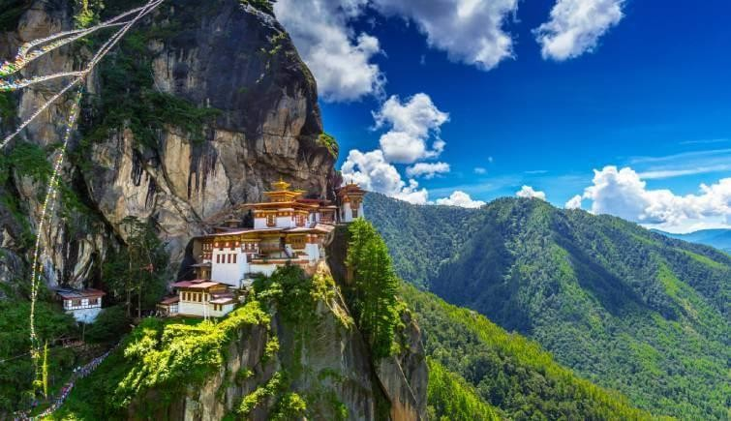

Bhutan, a Buddhist kingdom on the Himalayas’ eastern edge, is known for its monasteries, fortresses (or dzongs) and dramatic landscapes that range from subtropical plains to steep mountains and valleys. In the High Himalayas, peaks such as 7,326m Jomolhari are popular trekking destinations. Paro Taktsang monastery (also known as Tiger’s Nest) clings to cliffs above the forested Paro Valley
Capital: Thimphu Language: Dzongkha Tibeto-Burman language Religion: Buddhism
Must Eat : Ema Datshi, is a stew of chilies and cheese Shakam Datshi (dried beef with cheese), Kewa Datshi (potatoes with cheese),
TIME DIFFERENCE: + 30 MNS AHEAD OF INDIA VISA : Entry Pemit to be obtained.
Currencies: 1 Bhutanese Ngultrum equals = 1.00 Indian Official language: Dzongkha

Bhutan is not an ordinary place,. Be its colorful culture or enigmatic mountain,. The country of rolling hills and charming culture always exudes the charm that cannot be missed. Delightful people, dense forest, gigantic mountains and exclusive cuisine, always give a delightful experience. Bhutan is a place to experience and feel its warmth that will stay in your for lifelong.It evokes a sense of emotion that retains its opacity to keep you hooked. Bhutan is surprising and its traditions are visible.
A flight to Paro will be surely the most part of your journey overlooking the enigmatic snowy mountain calling
you to explore them. Bhutan is blessed with hilltop monasteries that brings out the peace which you desire to have during your visit. These monasteries are century old and are still strong in terms of construction and solace which is offered. Some of these monasteries are listed in the UNESCO Heritage List and introduces to the long-lasting religion.
Masked people, colorful clothes and music are enough to keep you hooked and create interests. Then there are textiles and handicrafts that showcase the true art of the people here. Bhutan is not only about festivals and monasteries, but also of thrilling mountain activities, river rafting and archery competitions which are the part of Bhutan travel. All these certainly makes Bhutan the Gross National Happiness country giving a different picture altogether. So pack your bags and head to this happy country, to visit the most awaited tourist places in Bhutan.
BHUTHAN
(4 NIGHTS 5 DAYS)
Duration : 04 Nights / 05 Days Destination : Thimphu (02 Nts) - Paro (02 Nts) Day 01 Paro Airport (PBH) Enroute Sightseeing - Thimphu
Thimphu (2320 Mts / 7656 Fts, 65 Kms / 01½ to 02 Hrs drive approx)

On arrival at Paro Airport and after completing your Visa / Permit formalities you will be received by our Bhutan representative who will assist you in boarding your vehicle for transfer from Paro Airport to Thimphu, the capital town of Bhutan. Based on time availability, en route stop at Tamchog Lhakhang (Iron Bridge) & Photo break at Chuzom (Confluence) Meeting point of Thimpu River (Wong Chu) & Paro River (Pa Chu). On arrival at Thimphu, check in to the Hotel. Overnight at Hotel.

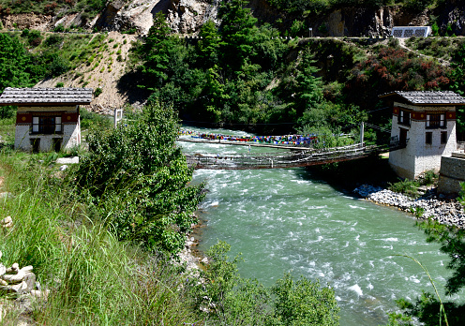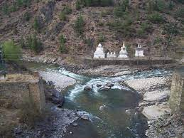
Day 02 Thimphu - Excursion To Punakha / Wangdi - Thimph u
Punakha / Wangdi (1273 Mts / 4177 Fts, 70 Kms / 03 to 3½ Hrs one way drive approx)

After breakfast drive to Punakha / Wangdi, which is the last town on the highway before entering Central Bhutan. The drive is over Dochu La pass (3080 Mts / 10102 Ft) which is very scenic with fascinating view of mountains of Bhutan.

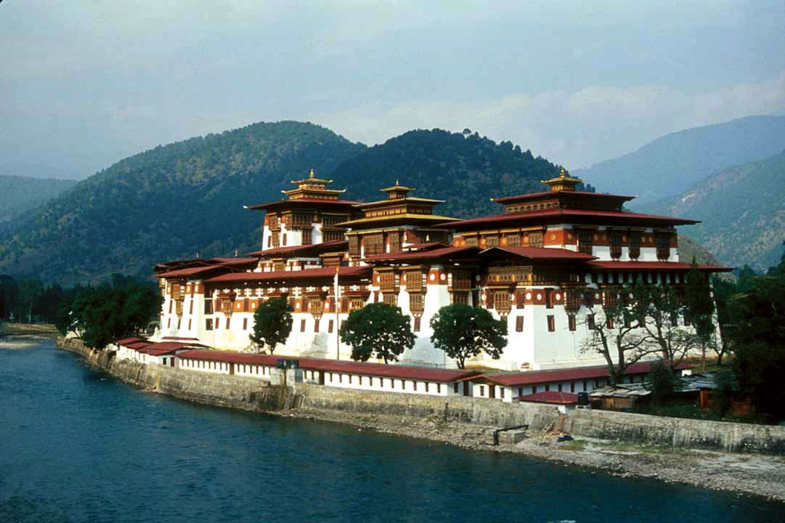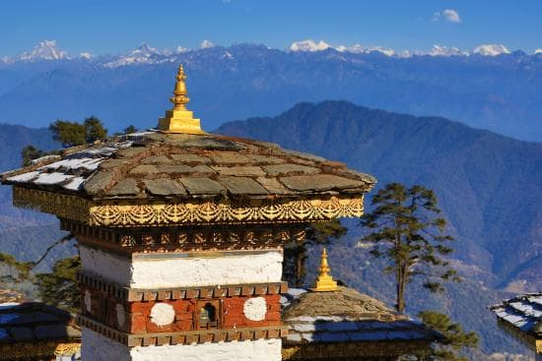

Visit Punakha Dzong. If time permit visit the Suspension Bridge and then proceed to Chimi Lhakhang (Monastery). Evening you drive back to Thimphu. Overnight at Hotel.

Day 03 Thimphu - Thimphu local sightseeing - Paro
Paro (2200 Mts / 7217 Fts, 52 Kms / 01½ to 02 Hrs drive approx)

After breakfasts, check out and then go for Thimphu sightseeing covering Sangaygang View Point (BBS Tower) which is located at an elevation of (2865 Mts / 9397Fts), which offers an exquisite view of the whole town of Thimphu, Then after visit Buddha Point (Kuensel Phodong) (Entrance fee INR 1000 (Approx) per person Adult / Child), Institute for Zorig Chusum (Traditional Art & Craft School) (Entrance fee INR 100 (Approx) per person Adult / Child) (Closed on Saturday , Sunday, National Holiday & During Summer & Winter Vacations), Textiles Museum (Entrance fee INR 250 (Approx) per person Adult / Child), Handicrafts Shops (Closed on Saturday,Sunday & National Holiday), Zangthopelri Lhakhang (Monastery), Simply Bhutan (Entrance fee INR 400 (Approx) per person Adult / Child) (Closed on National

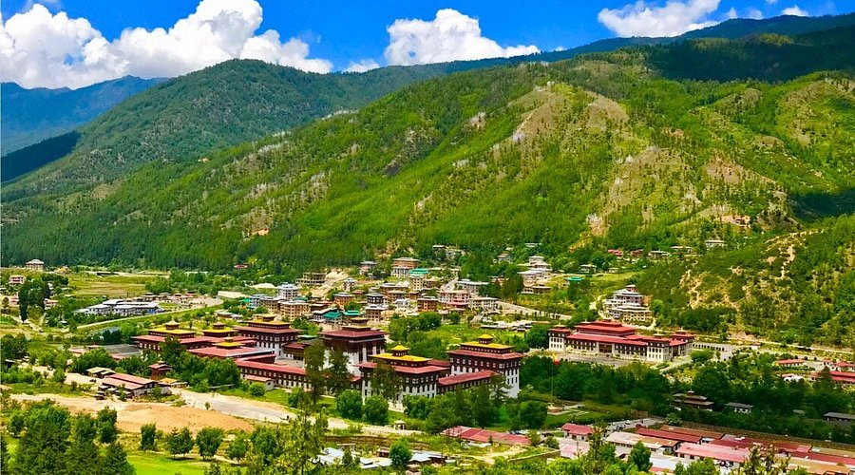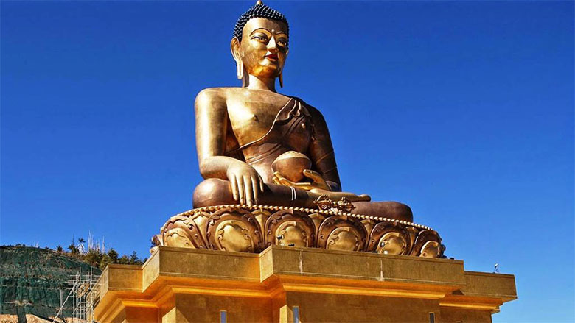

Holiday), Motithang Takin Preservation Centre (Entrance fee INR 300 (Approx) per person Adult / Child) (Closed on Every Monday). Later transfer to Paro. On arrival Paro, check in to the hotel. Overnight at Hotel.
Day 04 Paro - Full day Local Sightseeing - Paro Paro (2200 Mts / 7216 Fts)
After breakfast go for Full day Paro sightseeing covering of Dungtse Lhakhang, Then stop at Bird eye view point from this point picturesque Paro Valley can be seen from this point and the small Paro International airport in the middle of all of that looks stunning. Ideal time to go here would be between 10-11 AM.Then visit Ta Dzong (Entrance fee INR 150 (Approx) per person Adult / Child) (National Museum-Closed on National Holiday), Rinpung Dzong (Entrance fee INR 1000 (Approx) per person Adult / Child). Kichu Lhakhang. Afternoon visit the Paro local Market. Overnight at Hotel.

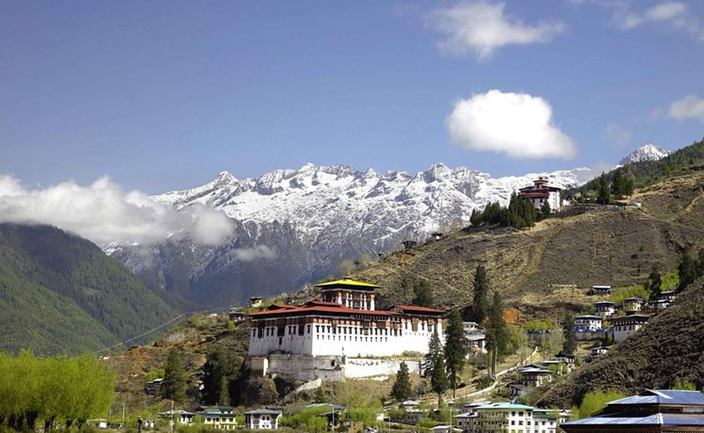

Or
Paro - Hike To Taktsang Lhakhang (Tiger’S Nest) - Paro (2200 Mts / 7216 Fts)
Start the day early for a day hike to Taktsang Lhakhang (Tiger's Nest Monastery) (Entrance fee INR 2000 (Approx) per person Adult / Child). The hike which is all the way uphill takes about 2 /3 hours one way through pine forests.
Afternoon free at leisure or go for shopping in the market. Overnight at Hotel.
Or
Paro - Excursion to Chele - la pass - Paro
Chele-la pass (3988 Mts / 13080 Fts, 40 Kms / 02 to 02 ½ Hrs. – One way drive approx. from Paro)
After breakfast go for a day excursion to Chele-la pass. Later drive back to Paro. Overnight at Hotel.

Day 05 Paro - Paro Airport (PBH)
Paro (2200 Mts / 7216 Fts, 6 Kms / 20 to 30 minutes drive approx.)
After breakfast checkout and then transfer from Paro to Paro Airport (PBH), for onwards connection.

TOUR ENDS

