Welcome to Azerbaijan
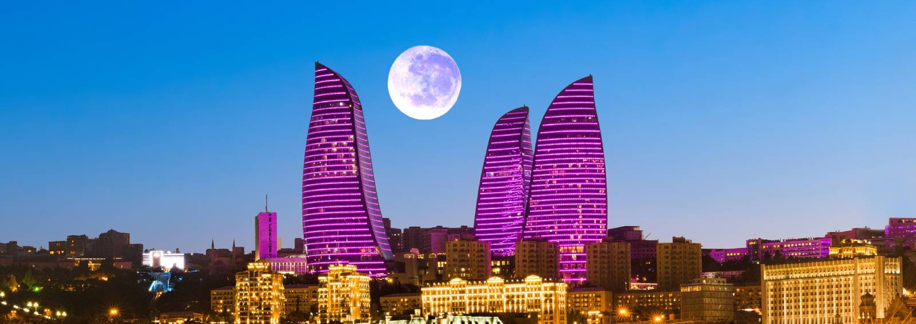

Azerbaijan, known as the "Land of Fire," is a captivating blend of ancient history and modern innovation. Located at the crossroads of Europe and Asia, it offers diverse experiences, from exploring the UNESCO-listed Old City of Baku to witnessing the natural wonders of mud volcanoes and the fiery hillside of Yanar Dag. The country is famed for its cultural heritage, vibrant bazaars, and delicious cuisine. With stunning landscapes ranging from the Caspian Sea coastline to the lush Caucasus Mountains, Azerbaijan is an emerging destination for nature lovers, history buffs, and adventure seekers alike

Baku is the capital and largest city of Azerbaijan, as well as the largest city on the Caspian Sea and of the Caucasus region. It is also known as "City of Winds” for its romantic climate. According to the Lonely Planet's ranking,
Baku is also among the world's top ten destinations for urban nightlife.

Capital: Baku Language: Turkic language Russian Religion: Shia Muslim Currency: 1 Azerbaijani Manat = 49.92 Indian Rupee Must Eat Specialty Food: (Pilaf) -Dolma, Qutab, Kebabs, and Levang . VISA: E – VISA TIME DIFFERENCE: + 1.5 hrs
Tourism Highlights
Explore Baku, Flame Towers and the Heydar Aliyev Center, designed by architect Zaha Hadid. Gobustan National Park, home to ancient petroglyphs, and Sheki, a town known for its scenic landscapes and historical architecture.

Baku – The Capital City : Heydar Aliyev Center: An architectural masterpiece by Zaha Hadid, known for its futuristic and fluid design. Old City (Icherisheher): A UNESCO World Heritage Site with historical landmarks like the Maiden Tower and Shirvanshah’s Palace. Flame Towers: Iconic skyscrapers illuminated at night, symbolizing Azerbaijan's nickname, the "Land of Fire." Baku Boulevard: A picturesque promenade along the Caspian Sea with entertainment options and great views.

Gobustan National Park : A UNESCO-listed site featuring ancient rock carvings, mud volcanoes, and archeological wonders. The park is known for its unique geological formations and petroglyphs dating back 40,000 years.

Absheron Peninsula : Ateshgah Fire Temple: A historical temple used by Zoroastrians, Hindus, and Sikhs, known for its eternal flames. Yanardag (Burning Mountain): A natural gas fire that burns continuously on the hillside.

Sheki : Sheki Khan’s Palace: A stunning 18th-century palace with intricate stained-glass windows and beautiful frescoes. Caravanserai: Historical inns that were once stops on the Silk Road, now repurposed as hotels and cultural attractions.

Gabala : A popular destination for nature and adventure enthusiasts, with lush forests, waterfalls, and ski resorts in winter. Tufandag Mountain Resort: Offers skiing, cable car rides, and scenic views.Naftalan Famous for its unique therapeutic crude oil spas, believed to have healing properties.

Ganja Azerbaijan’s second-largest city, known for its historical mosques, parks, and the Nizami Mausoleum, dedicated to the famous Persian poet.

Caspian Sea Beaches: The Caspian coast offers resorts and beachside relaxation, particularly in areas like Bilgah and Nabran.

Wine Tourism: Azerbaijan has a growing wine industry with vineyards in regions like Gabala and Ganja offering tours and tastings. Nakhchivan : An exclave of Azerbaijan with unique attractions like the Mausoleum of Momine Khatun and the stunning Alinja Castle.

Cuisine Highlights: Plov: A flavorful rice dish with saffron, nuts, and dried fruits. Dolma: Stuffed grape leaves with spiced meat or vegetables. Lavangi: Chicken or fish stuffed with walnuts, onions, and herbs. Azerbaijani Tea Culture: Served with jams and sweets, tea is a staple of hospitality.

Azerbaijan
(4Nights 5Days)
DAY – 1 WELCOME TO BAKU
❖ Arrival at Airport. Transfer from Airport to Hotel .Early Morning Check Inn not included
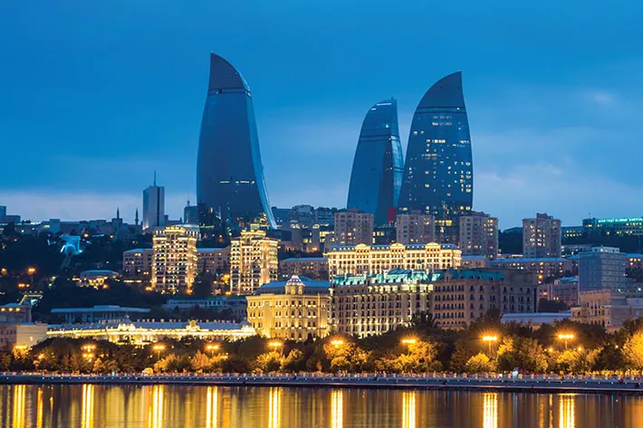
DAY – 2 BAKU CITY TOUR + PANAROMIC TOUR
❖ Breakfast in Hotel
❖ 10:00 Tour starts with the visit to the charming example of modern architecture - The Heydar Aliyev Center– a 57,500 m2 building complex in Baku, Azerbaijan designed by Iraqi-British architect Zaha Hadid and noted for its distinctive architecture and flowing, curved style that eschews sharp angles. The center is named after Heydar Aliyev, the first secretary of Soviet Azerbaijan from 1969 to 1982, and president of Azerbaijan Republic from October 1993 to October 2003. (Photo shoot outside)
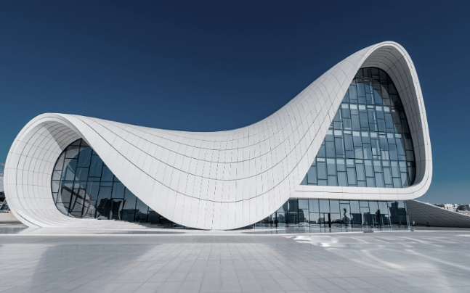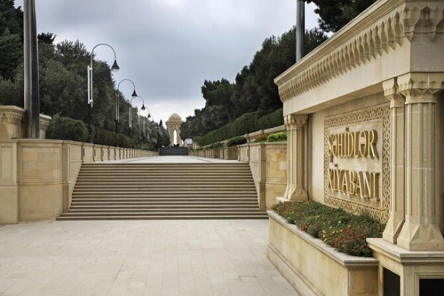
❖ 13:00 lunch
❖ 17:00Assembly at lobby. Start tour. Visit to Highland Park-Alley of Martyrs, The National Assembly- also transliterated as Milli Majlis, Flame towers-the tallest skyscraper in Baku.
❖ Walking through Baku Boulevard which stretches along a south-facing bay on the Caspian Sea. It traditionally starts at Freedom Square continuing west to the Old City and beyond. Since 2012, the Yeni Bulvar (New Boulevard) has virtually doubled the length to 3.75 km.
❖ Later experience the happening street of Nizami Street known for Shopping. The Street’s history could be traced back to Baku's town-planning project of 1864. The street runs through the city's downtown from west to east. It begins from Abdulla Shaig Street, in mountainous part of the city and ends at railroad bed on Sabit Orujov Street, near a monument to Shah Ismail Khatai in “Black City”.
❖ 20:00 dinner Free time – can explore night activities at you own
❖ Overnight in hotel
❖ Meals: Breakfast+ Lunch + Dinner
DAY – 3 FLAME TOUR + OLD CITY TOUR
❖ Breakfast in Hotel
❖ 10:00 Assembly at hotel lobby. Tour starts with Ateshgah (Fire Worshippers Temple)

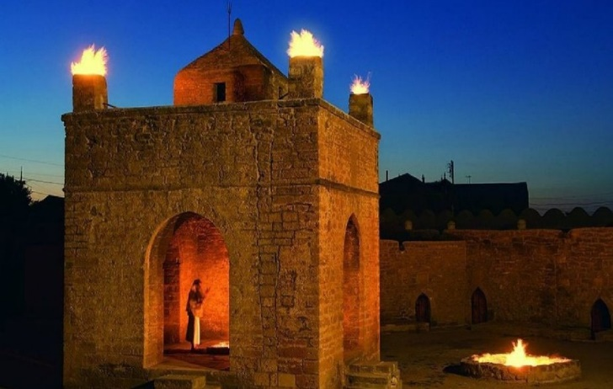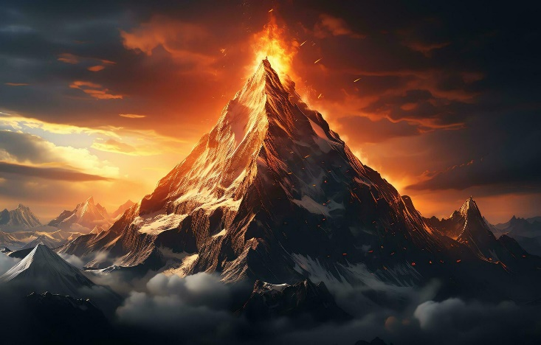
❖ Based on Persian and Indian inscriptions, the temple was used as a Hindu and Zoroastrian place of worship. "Atash” is the Persian word for fire. The pentagonal complex, which has a courtyard surrounded by cells for monks and a tetra pillar-altar in the middle, was built during the 17th and 18th centuries. It was abandoned in the late 19th century, probably due to the dwindling of the Indian population in the area. The natural "eternal flame" went out in 1969, after nearly a century of exploitation of petroleum and gas in the area, but is now lit by gas piped from the nearby city
❖ Trip to "Fire Mountain "-"Yanardag" – a mountain on Abs heron peninsula, 25 km from north of Baku. Literally, word "Yanardag" means "Blazing Mountain". Blazing bodies of flame dance on stones and floor. Yanar dag is a natural gas fire which blazes continuously on a hillside on the Absheron Peninsula on the Caspian Sea near Baku, the capital of Azerbaijan, which itself is known as the "land of fire."
❖ 13:00 Lunch
❖ 10:00Our tour program starts with Old City or Inner City is the historical core of Baku, the capital of Azerbaijan. The Old City is the most ancient part of Baku, which is surrounded by walls were well protected. In 2007, the Old City had a population of about 3000 people. In December 2000, the Old City of Baku, including the Palace of the Shirvanshahs and Maiden Tower, became the first location in Azerbaijan to be classified as a World Heritage Site by UNESCO (walking tour)
❖ 20:00Transfer for dinner at Indian restaurant at 2000 hrs
❖ Transfer to hotel at 2230 hrs Free time – can explore night activities at you own
❖ Overnight in hotel
❖ Meals: Breakfast+ Lunch + Dinner
DAY – 4 GOBUSTAN + SHOPPING TOUR
❖ Breakfast at the hotel
❖ 10:00Tour starts with Qobustan which is best known for being the home to the famous rock petroglyphs. The area has been settled since the 8th millennium BC. It is known for hosting thousands of rock engravings spread over 100 square km depicting hunting scenes, people, ships, constellations and animals. Its oldest petroglyphs date from the 12th century BC. In 2007, UNESCO included the ‘Gobustan Rock Art Cultural Landscape’ in the World Heritage list.
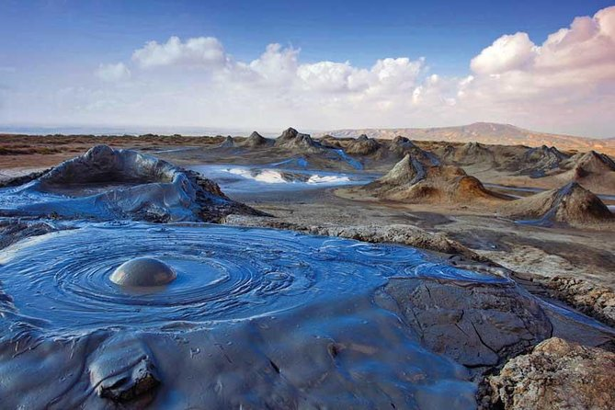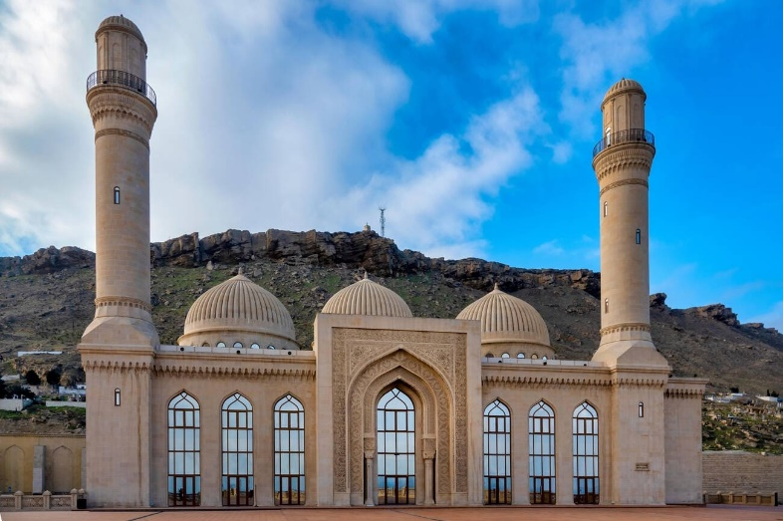
❖ Visit to the Bibi – Heybat Mosque– historical mosque in Baku, Azerbaijan. The existing structure, built in the 1990s, is a recreation of the mosque with the same name built in the 13th century by Shirvanshah Farrukhzad II Ibn Ahsitan II
❖ 14:00 lunch
❖ 16:00 Start Shopping tour with Local Sweet Shop, Azerbaijan Brand: Aliahmad’S
❖ Proceed to Local vine and alcoholic drinks shop
❖ Continue with “Xurcun”dry fruits and sweets shop
❖ Genclik Mall: - located in 10 minutes’ distance form city center with taxi. Genclik mall is the biggest Mall in Baku and contains over 80 stores, big bowling halls, the biggest movie halls, 3D cinema, Playground for children, Bravo supermarket, VIP restaurants, food courts
❖ 20:00 dinner
❖ Free time – can explore night activities at you own
❖ overnight in hotel
❖ Meals: Breakfast + Lunch + Dinner
DAY – 5 DAY AT LEISURE + DEPARTURE
❖ Breakfast in Hotel
❖ 12:00 Check out Hotel.
❖ Day free for shopping
❖ Meals: Breakfast + Lunch + dinner
❖ Transfer to airport at 2200hrs to catch flight back home.

Tour Ends

